**Spencer Gifts – OMS**

**PO Cost Adjustment Request and Approval**

**Business Flow Document**

**

Prepared by : Shashi Kiran Goud Akkala

Reviewed by : Sarvani Josyam

Date Submitted : 03/09/2021

Version : 0.1

Last revised date : 03/092021

This document is being submitted to **Spencer Gifts** by **WinWire Technologies, Inc**. This document and any supporting appendices submitted with it are confidential and intended solely for the use of the business users and IT team working at **Spencer Gifts**.

**Revision History**

**Change Record**

|  |  |  |  |
| --- | --- | --- | --- |
| **Date** | **Author** | **Version** | **Change reference** |
| 3/09/2021 | Shashi Kiran Goud Akkala | 0.1 | Initial draft. |
|  |  |  |  |
|  |  |  |  |
|  |  |  |  |

**Reviewers**

|  |  |  |  |
| --- | --- | --- | --- |
| **Name** | **Version approved** | | **Date** |
| Sarvani Josyam | 0.1 |  | |
|  |  |  | |
|  |  |  | |

Table of Contents

1.1 Cost Adjustment Page 5

1.1.1 Navigating from PO page. 5

1.2 Cost Adjustement Fields 6

1.2.1 Default Reason Field ----------------------------------------------------------------------- 6

1.2.2 Threshold -------------------------------------------------------------------------------------- 6

1.3 Included SKU'S Section ------------------------------------------------------------------------- 8

1.4 Uploaded Files Section ------------------------------------------------------------------------- 8

1.5 Saving A Cost Adjustment --------------------------------------------------------------------- 8

1.6 Cost Adjustment Creation Based On Roles ----------------------------------------------- 8

1.6.1 Buyer ------------------------------------------------------------------------------------------11

1.6.2 Buyer-CC ------------------------------------------------------------------------------------16

1.6.3 BuyerST-------------------------------------------------------------------------------------- 18

1.6.4 BuyerST-CC -------------------------------------------------------------------------------- 22

1.6.5 MerchOps ----------------------------------------------------------------------------------- 24

1.6.6 MerchO-CC -------------------------------------------------------------------------------- 28

1.6.7 MerchO-IC --------------------------------------------------------------------------------- 32

1.6.8 BuyerST-IC -------------------------------------------------------------------------------- 37

1.6.9 Buyer-IC ------------------------------------------------------------------------------------ 43

1.7.0 BuyerVC------------------------------------------------------------------------------------- 47

1.7.1 BuyerST-VC ------------------------------------------------------------------------------- 51

1.7.2 MerchO-VC -------------------------------------------------------------------------------- 55

1.8 Cost Adjustment Menu Items ---------------------------------------------------------------- 58

1.9 Rules ----------------------------------------------------------------------------------------------- 59 2.0 Notification Emails --------------------------------------------------------------------------------- 59

## Cost Adjustment Page

### Navigating from PO page.

1. We see a “Cost Adjustment section” in PO detail page. We can have multiple Cost Adjustment requests for a PO.

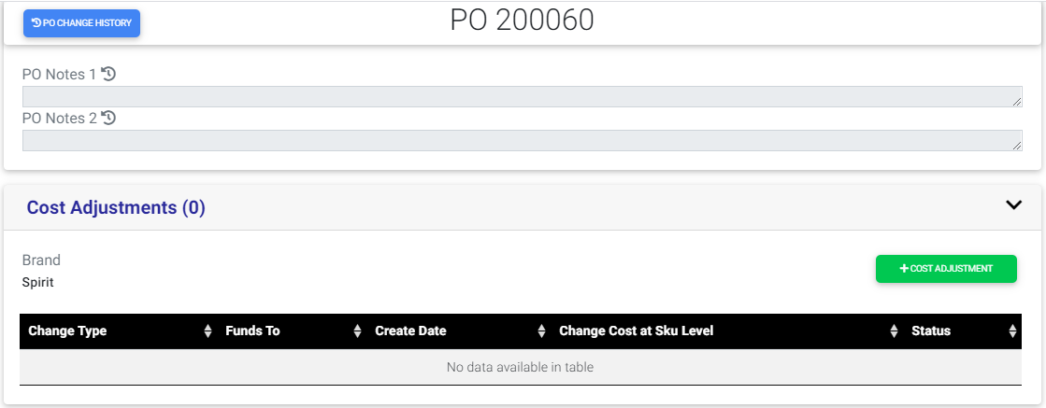

1. A button named Create Cost Adjustment will be seen only if there are no Cost Adjustment requests and incase if the requests are present there status must be closed.
2. If Cost adjustment is not created earlier, on click of Create Cost Adjustment button, it will navigate to cost adjustment screen which allows user to create the request.

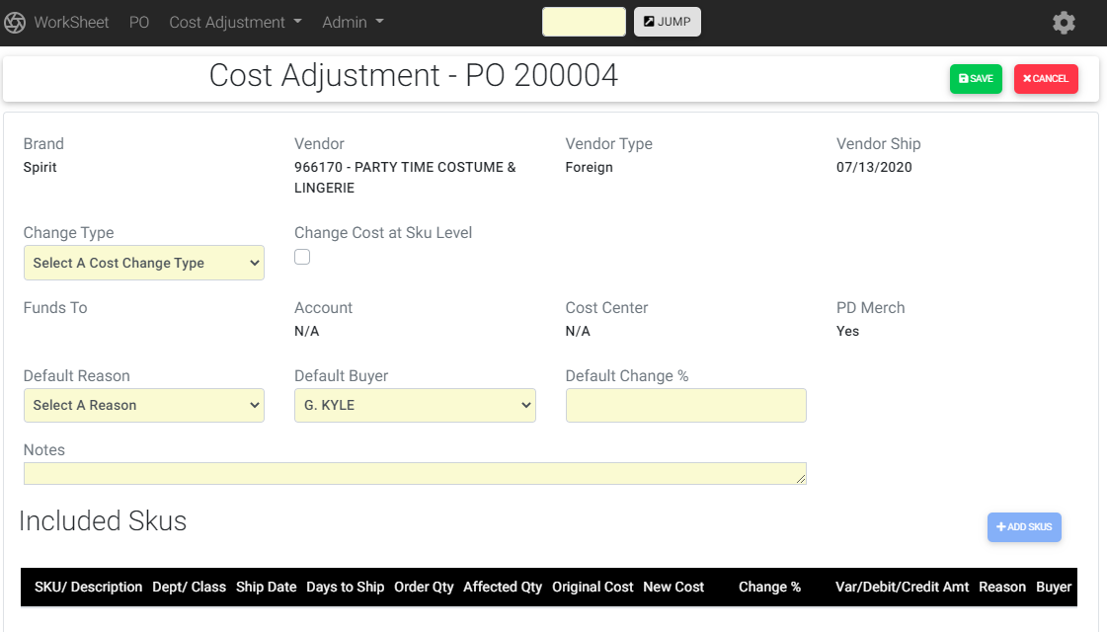

1. If a Cost Adjustment is created already, then we can see a request with the status ‘UA’ and when we click that request it will navigate to read only view of the cost adjustment screen.

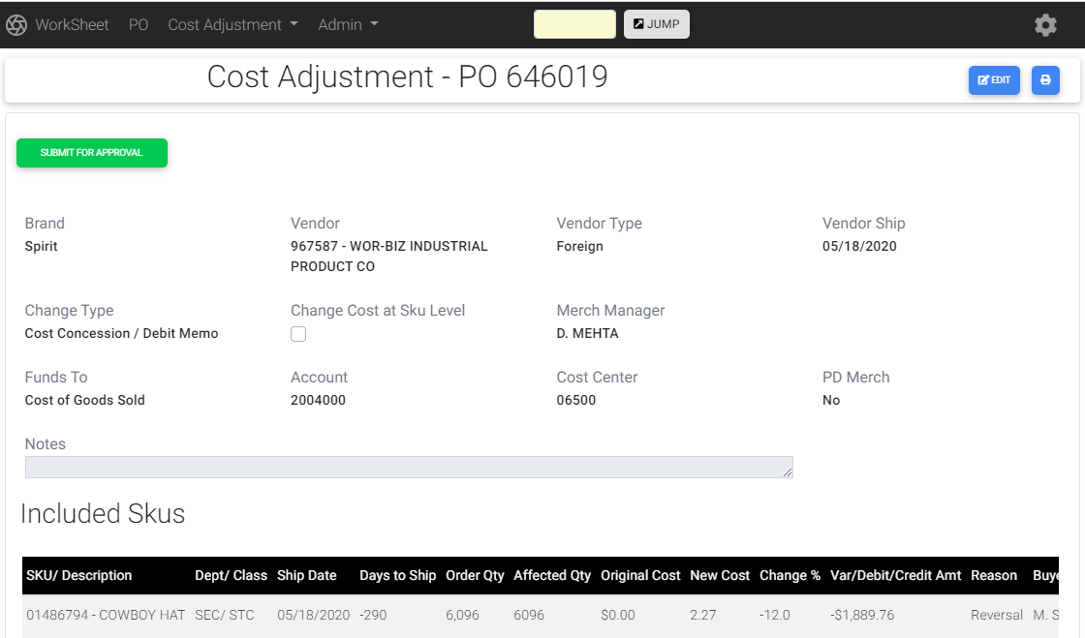

1. If the is user in a role related to Cost Adjustment, only then Cost Adjustment section is visible. Otherwise user can’t view the Cost Adjustment section in a PO page.

## Cost Adjustment Fields:

1. Brand, Vendor, Vendor Type and Vendor Ship date will be populated from PO.
2. Change Type, Funds To, are the required fields. Change Type is a drop down with Cost Change, Credit Memo and Cost Concession /Debit memo values. Credit Memo accepts positive values and Debit accepts negative values. So for credit memo Default Change % will accept only positive and for Debit Default Change % will accept only negative values.
3. In Change Type drop down cost change will be populated if it satisfies below conditions:

* PO should not have receipts.
* If PO type is Domestic today’s date should be less than ship date.
* If PO type is foreign import days count must be less than the total days count. (Total days count = exclude ship date with today’s date and take the count)

1. Account field will be populated based on selected Funds To value and Cost Center by brand and Funds To value.
2. Financial Direction is a field having checkbox and depends on reason “Intended Cost Change” in reason dropdown.
3. Comments Field is also present in header section where user can provide their comments.
4. Default Reason, Default Buyer and Default Change % are the required fields and are present in Header and Included SKU’s section as well. Buyer and reason are drop down’s with predefined values. The values selected in Header section will be populated in Included SKU’s section as well and users can modify them in SKU level also.
5. Default Buyer, Default Change and Default Reason are optional dropdown fields with predefined values which will be applied to all the SKU’s in the Included Section.

### Default Reason Field:

1. A default reason called “Intended Cost Change” is available in Default Reasons dropdown list only for Debit and Credit memo types, PO ship date is present day or earlier, PO is Foreign/Import and PO must not have any receipts. Once user selects it then change cost at SKU level gets checked and Cost Of Goods Sold value will be shown in Funds To dropdown.

## Threshold:

1. For a worksheet, if the SKUs change % is in between +/- 10, it is referred to as Threshold.
2. Threshold value is applicable only for Spirit brand.
3. When the brand of a PO is spirit if the change % value is within threshold then Merch Manger drop down will not be visible and skips the Merch Manager approval workflow and will be submitted directly to Finance.
4. When the brand of a PO is spirit and if the change % is not within threshold then Merch Manger drop down will be visible.
5. By default for a Spencer worksheet Merch Manager drop down is visible and it is a required field.
6. Merch Ops role doesn’t have a Threshold and Merch Manger drop down will not be visible and request created by Merch Ops directly goes to Finance step.

## Included SKU’s Section:

1. Below Header details section we have Included SKU’s section. It will have a Add SKU’s button where user can add the SKU’s and it is enabled only if Cost Change Type value is selected.
2. Once user clicks the ADD SKU’s button a popup gets opened which lists all SKU’s in that PO. Only non-cancelled SKU’s that have not already been included in Cost Adjustment request will be shown.
3. A check box is provided for every SKU to select and a check box to select all SKUs if user wants to select all SKUs.

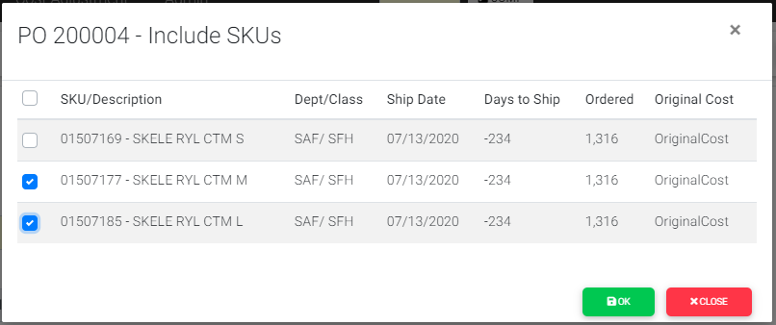

1. Once user clicks OK then the selected SKUs will get added to the Cost Adjustment screen.
2. All the selected SKUs are displayed in a grid in Cost Adjustment screen from the Popup.
3. Affected value, New Cost, Change Percent, Var/Debit/Credit/Amt fields are available in this section. Few of the fields are editable and few are in read only mode.

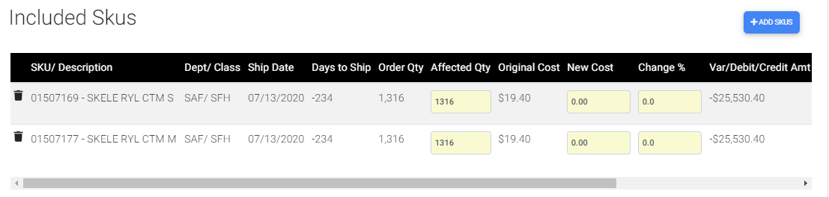

1. Every SKU needs to have a delete icon to delete it from the grid and the deleted SKU should be available in the Popup to add it for the next time. Affected Qty, New Cost and Change % in the grid are editable and those values will be calculated and will be displayed when user changes any data. If change type is debit then change percent, Var/Debit/Credit Amt field, should be negative and new cost value can be negative or positive. For Credit memo change percent, new cost should be positive.
2. User can view the list of Incomplete , Complete , Unsubmitted and Submitted request based on roles

* Finance can view all the requests irrespective of Brand.
* If in Merch Merchandise Ops and Merchandise Manager roles can view only those for the same brands(Spirit / Spencer).
* If a Buyer Spencer’s may only see Spencer’s and the same for Spirit.

1. In Incomplete/Complete/Unsubmitted/Submitted lists we have Type, Next Approver columns to filter the requests based on those fields.

## Uploaded Files Section:

1. Creator/Approver can upload one or more files by clicking ‘Add Files’ button.
2. The user can remove any uploaded files and can download as well.

## Saving a Cost Adjustment:

1. Cost Adjustment screen should be scrollable with fixed header which will have a Save, Cancel buttons in Edit mode. The header will have Edit button in read only view.

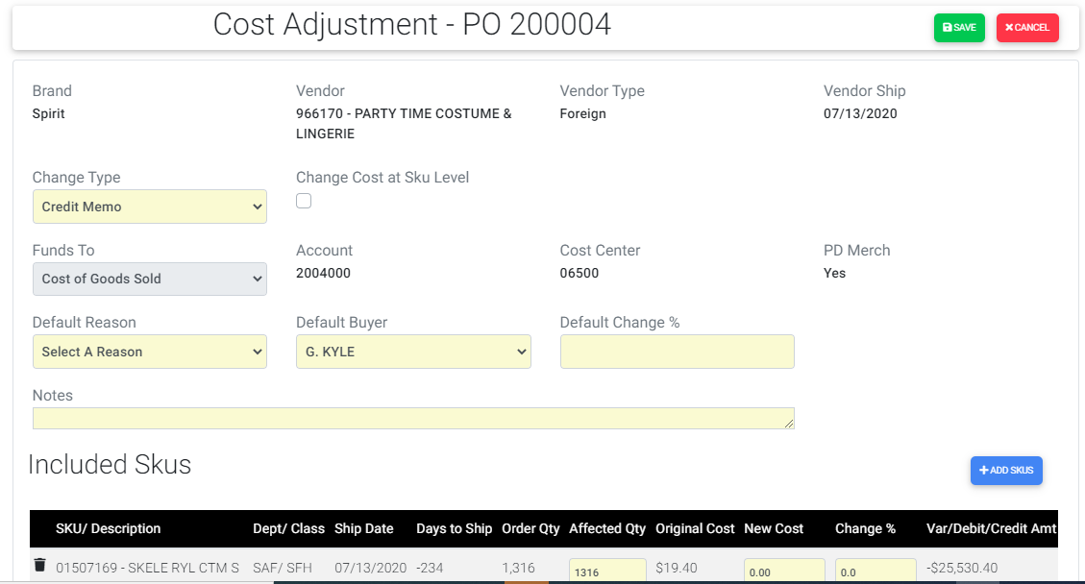

1. When any user updates or submits a change request having SKU with a cost change % greater than configured number(20) then a warning message will be populated to confirm the change % value.
2. Only Buyer/ Merch Ops can create a Cost Adjustment request and submit the request.
3. Different workflows are triggered based on roles and few conditions.

## Cost Adjustment Request creation based on Roles:

### Buyer:

1. User is in buyer role and navigates to cost adjustment and selects change type as Cost Change and change percent value above threshold ie(other than -10 to 10). PO type can be either Foreign or Domestic. Since change percent is not in the range of threshold Merch Manger drop down will be visible and user enter the data for required fields and then creates request for a Spirit PO. Submit For Approval button will be visible.

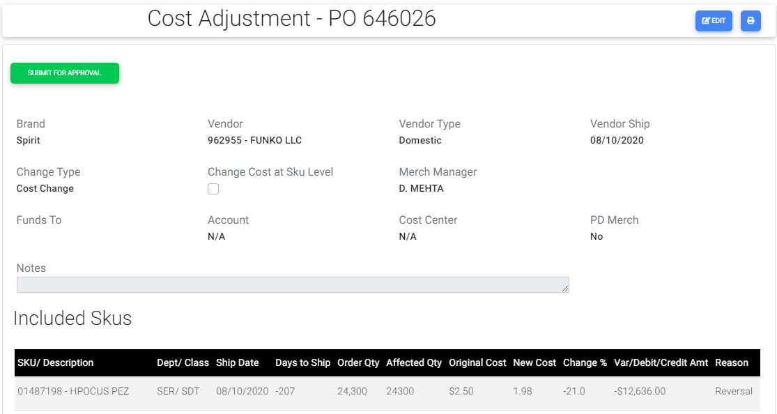

1. When a request is submitted without having attached a file then a confirmation warning message will be displayed when Submit button is clicked.
2. When Buyer creates a Cost Adjustment request and if not submitted request goes under Unsubmitted lists.
3. When buyer clicks the Submit For Approval button then the request is submitted and the workflow is generated with two steps as below:

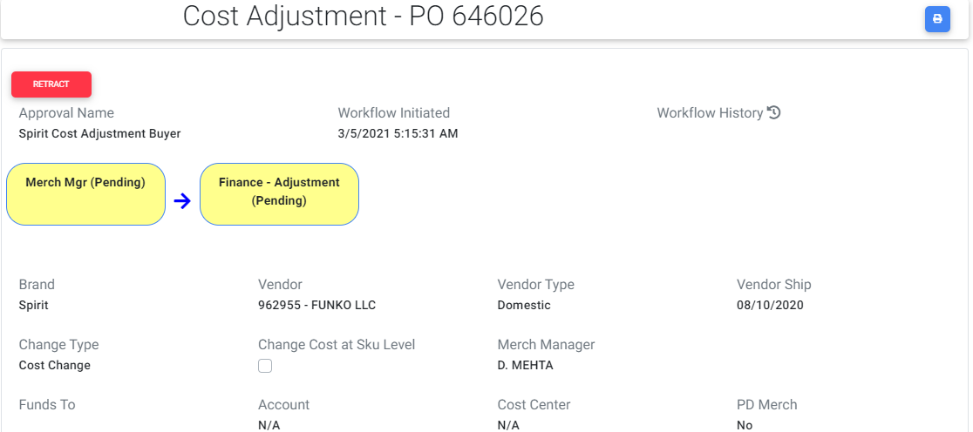

1. For Buyer Retract button is visible until the request is completed by Finance. When Buyer clicks the Retract button buyer can submit the request again.
2. If Buyer submits the request then request moves from Unsubmitted to Incomplete lists.
3. If buyer retracts the request or Merch Manager / Finance rejects the request then the request goes back to Unsubmitted lists from Incomplete lists.
4. Now for the Merch Manager role Approve and Reject buttons are visible.

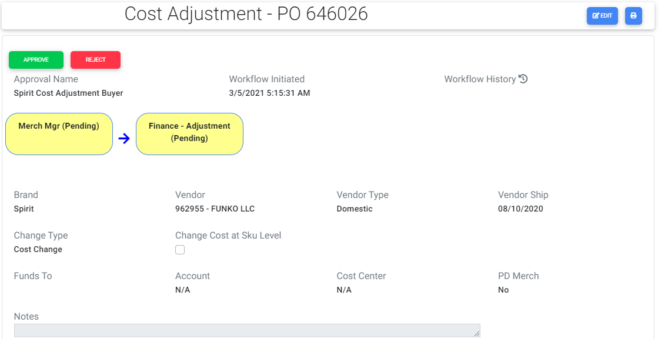

1. Once Merch Manger approves the request Merch Manger’s step status changes from Pending to Approved.

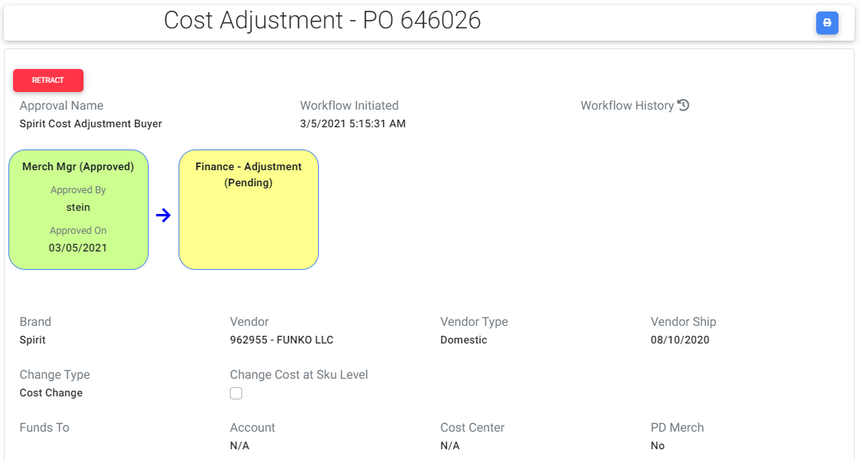

1. Incase if Merch Manager clicks Reject button the request will be rejected and again the buyer should submit the request.
2. Retract button is visible for Merch Manger until the request is completed by Finance.
3. If Merch Manager clicks the Retract button once again Approve and Reject buttons are visible.
4. For Finance role Complete Adjustment and Reject buttons are visible.

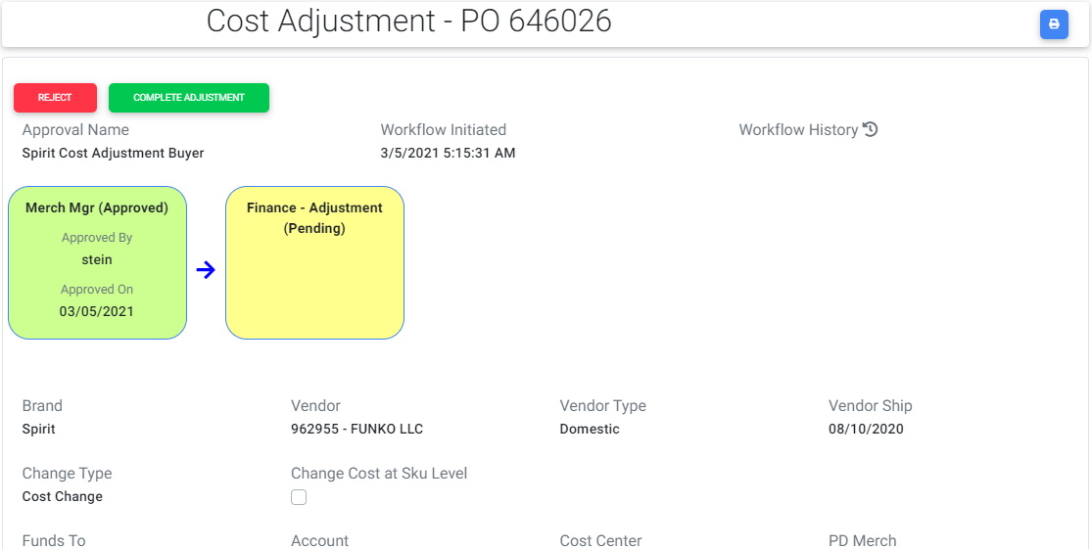

1. Once Finance user clicks the Reject button once again buyer needs to submit the request and workflow will be restarted again.
2. If Finance user clicks the Complete button then the Finance- Adjustment step changes from Pending to Approved.

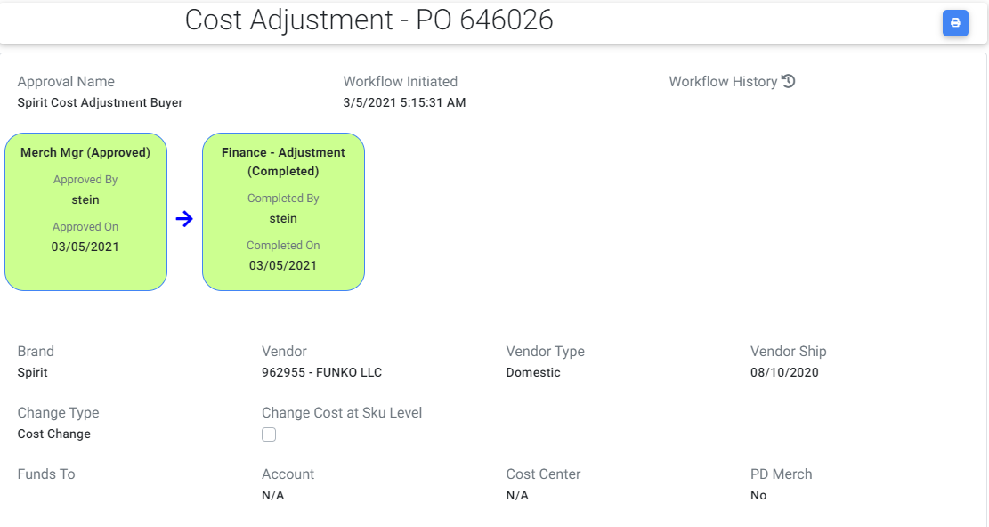

1. If Finance completes the request then the request moves from Incomplete to Completed lists.
2. A print icon is visible at top right corner of cost adjustment request once if user clicks that icon, request will be navigated to read only screen where user can take a print of the request.
3. The same steps are repeated for Spencer worksheet and the only difference is there is no threshold value and by default Merch Manager field is visible and it is a required field.

### Buyer-CC:

1. User is in buyer role and navigates to cost adjustment screen and selects Change type as Credit / Debit memo, PO type as Domestic and change percent value above threshold ie (other than -10 to +10). Since change percent is not in the range of threshold Merch Manger drop down will be visible and user enters the required data and then creates the request for Spirit PO. Submit For Approval button will be visible.

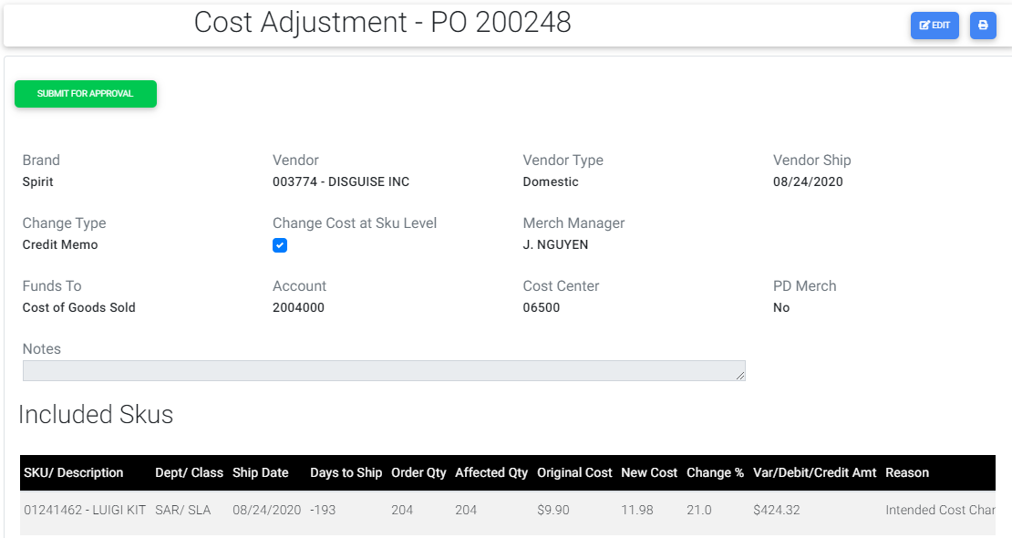

1. When a request is submitted without having attached a file then a confirmation warning message will be displayed when Submit button is clicked.
2. When Buyer creates a Cost Adjustment request and if not submitted request goes under Unsubmitted lists.
3. When Buyer clicks the Submit For Approval button then the request is submitted and the workflow is generated three steps as below.

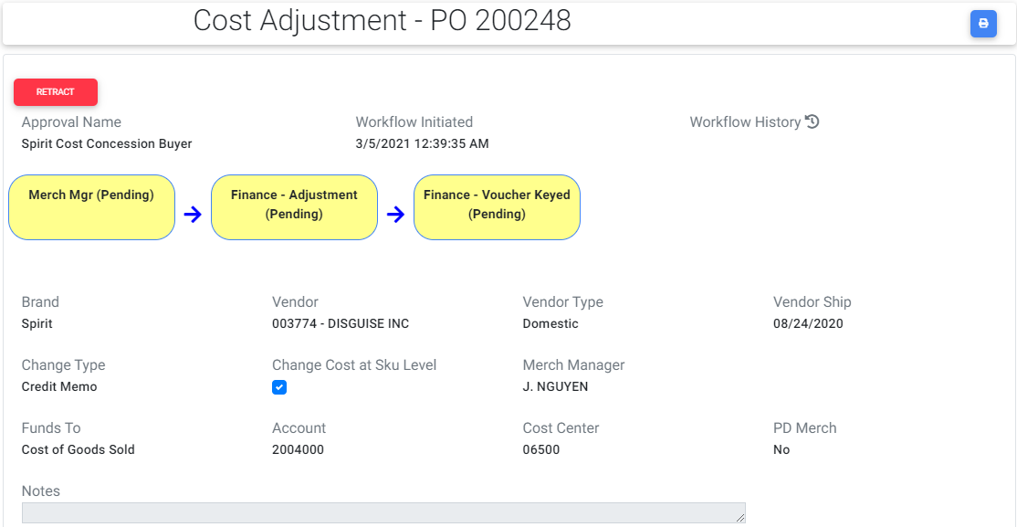

1. If Buyer submits the request then request moves from Unsubmitted to Incomplete lists.
2. For Buyer Retract button is visible until request is completed by Finance. When Buyer clicks the Retract button buyer can submit the request again.
3. Now for the Merch Manager role Approve and Reject buttons are visible.

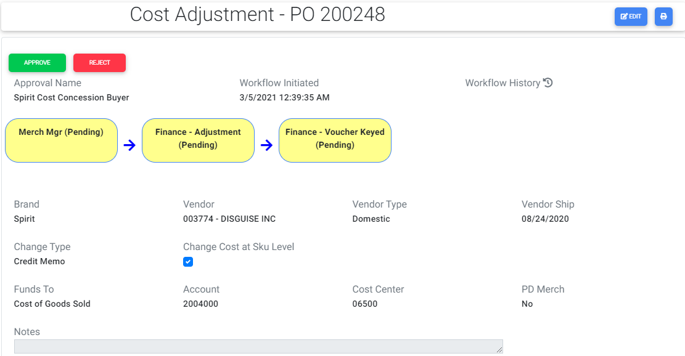

1. If Merch Manager approves the request the Merch Manger’s step status changes from Pending to Approved.

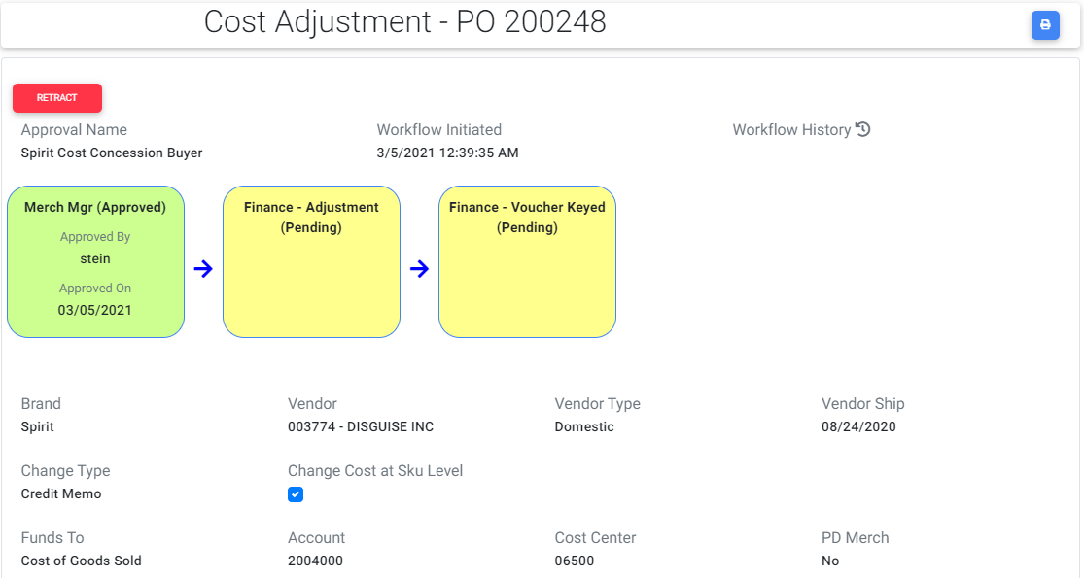

1. Incase if Merch Manager clicks Reject button the request will be rejected and again the buyer should submit the request.
2. Retract button is visible for Merch Manger until the request is completed by Finance.
3. If Merch Manager clicks the Retract button once again Approve and Reject buttons are visible.
4. If buyer retracts the request or Merch Manager / Finance Rejects the request then the request goes back to Unsubmitted lists from Incomplete lists.
5. For Finance role Complete Adjustment Reject buttons are visible.

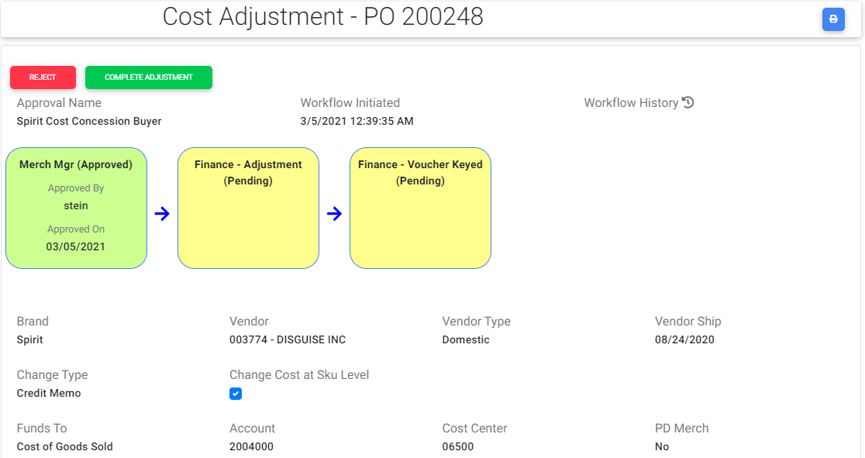

1. If Finance user clicks the Reject button once again buyer needs to submit the request and workflow will be restarted again.
2. If Finance user clicks the Complete button then the Finance- Adjustment step changes from Pending to Approved.

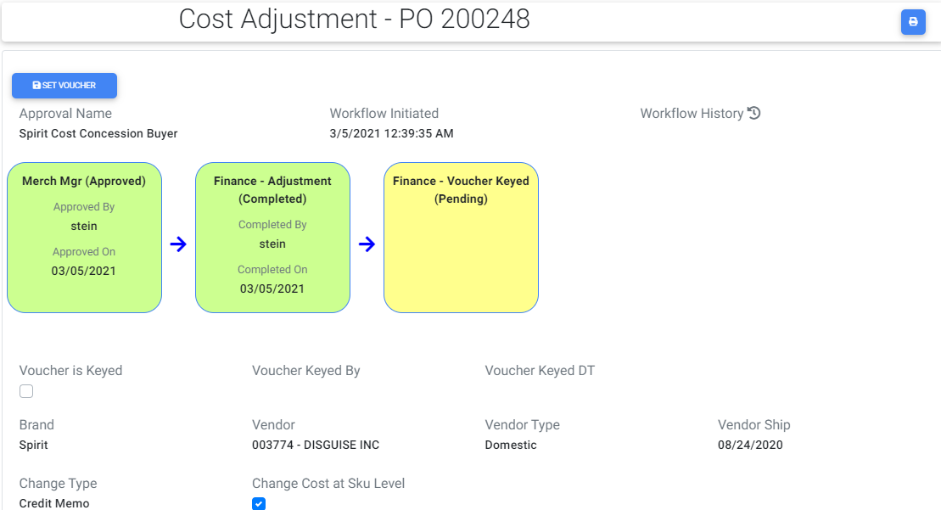

1. If Finance completes the request then the request moves from Incomplete to Completed lists.
2. Now Set Voucher button will be displayed and once when he clicks that button a popup will be displayed with a check box.

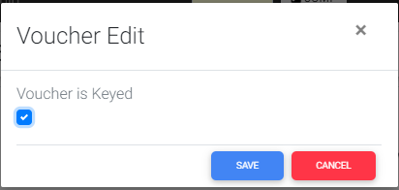

1. If finance user checks and saves it the Finance-Voucher Keyed step status changes from Pending to Approved.

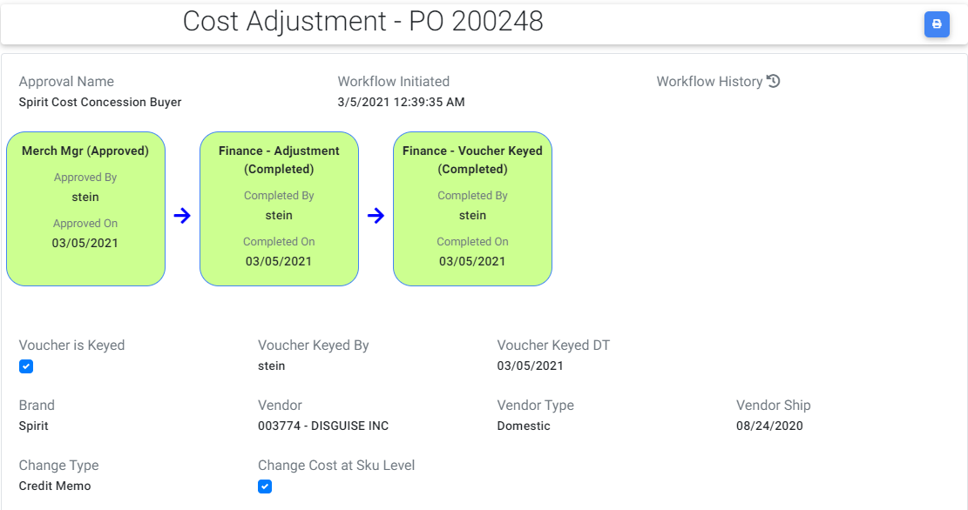

1. A print icon is visible at top right corner of cost adjustment if user clicks that icon, request will be navigated to read only screen where user can take a print of the request as per there requirements.
2. The same steps are repeated for Spencer worksheet and the only difference is there is no threshold value and by default Merch Manager field is visible and it is a required field.

### BuyerST:

1. User is in Buyer role and navigates to cost adjustment screen and selects cost change as change type, PO type can be either Domestic/Foreign and gives the change percent value within threshold for a Spirit PO. Since change percent is within threshold Merch Manger drop down will not be visible and adjustment request skips the Merch Managers approval and directly goes to Finance. User enters the data for required fields and creates a cost adjustment request. Submit To Finance button will be visible.
2. When a request is submitted without having attached a file then a confirmation warning message will be displayed when Submit button is clicked.
3. When Buyer creates a Cost Adjustment request and if not submitted request goes under Unsubmitted lists.

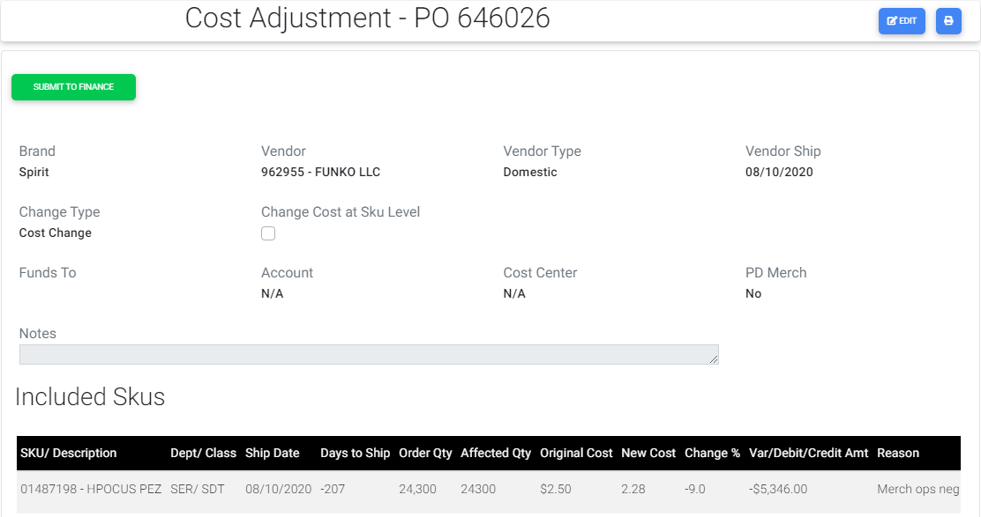

# When buyer clicks the Submit To Finance button then the request is submitted and the workflow is generated with one step as below:

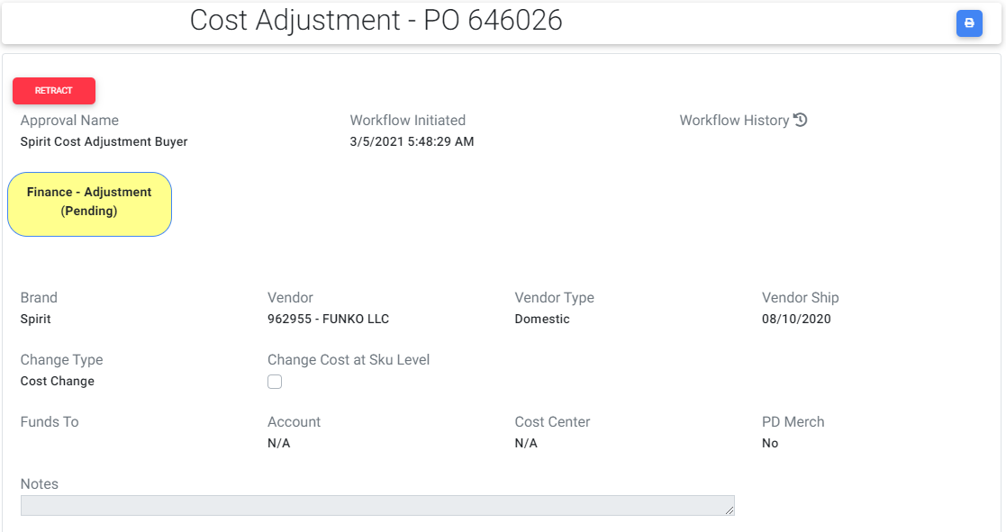

# If Buyer submits the request, then request moves from Unsubmitted to Incomplete lists.

# If buyer retracts the request or Finance Rejects the request, then the request goes back to Unsubmitted lists from Incomplete lists.

# For Buyer Retract button is visible until the request is completed by Finance. When Buyer clicks the Retract button he can submit the request again.

# Now for Finance role he can see the Complete Adjustment button and Reject button.

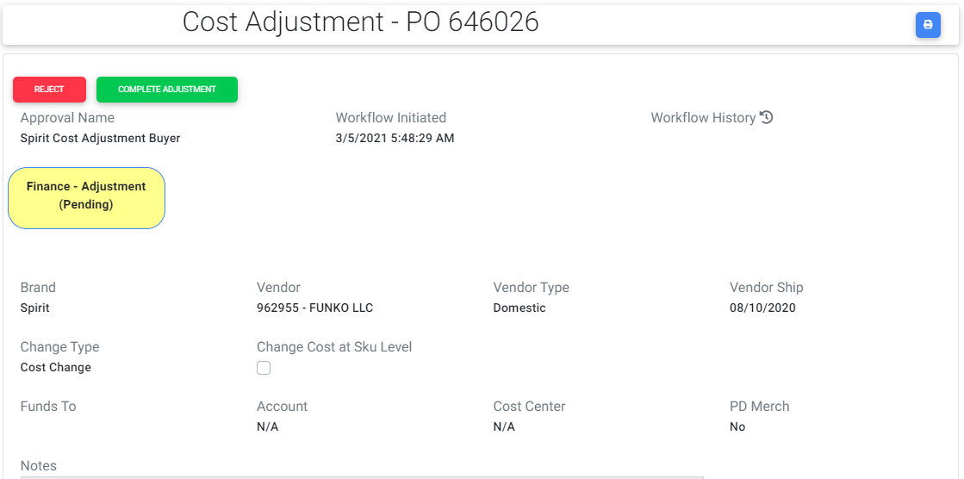

# If Finance user clicks the Reject button once again buyer needs to submit the request and workflow will be restarted again.

# If Finance user clicks the Complete button then the Finance- Adjustment step changes from Pending to Approved.

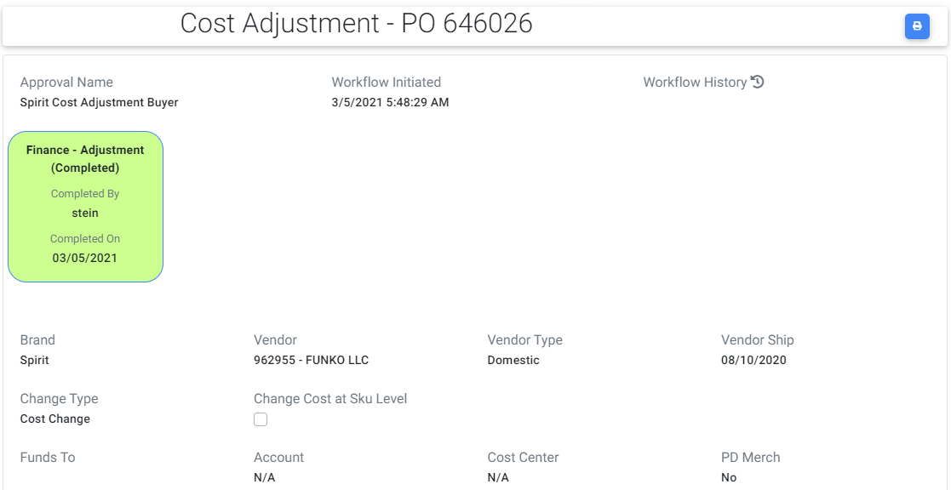

# If Finance completes the request then the request moves from Incomplete to Completed lists.

# A print icon is visible at top right corner of cost adjustment request once if user clicks that icon, request will be navigated to read only screen where user can take a print of the request as per there requirements.

## 1.6.4 BuyerST-CC:

# User is in Buyer role and navigates to cost adjustment screen and selects Change type as Credit / Debit memo and change percent value within threshold for a Spirit PO. Since change percent is within threshold Merch Manger drop down will not be visible and adjustment request skips the Merch Managers approval and directly goes to Finance. User enters the require data and creates a Cost Adjustment request. Submit To Finance button will be visible.

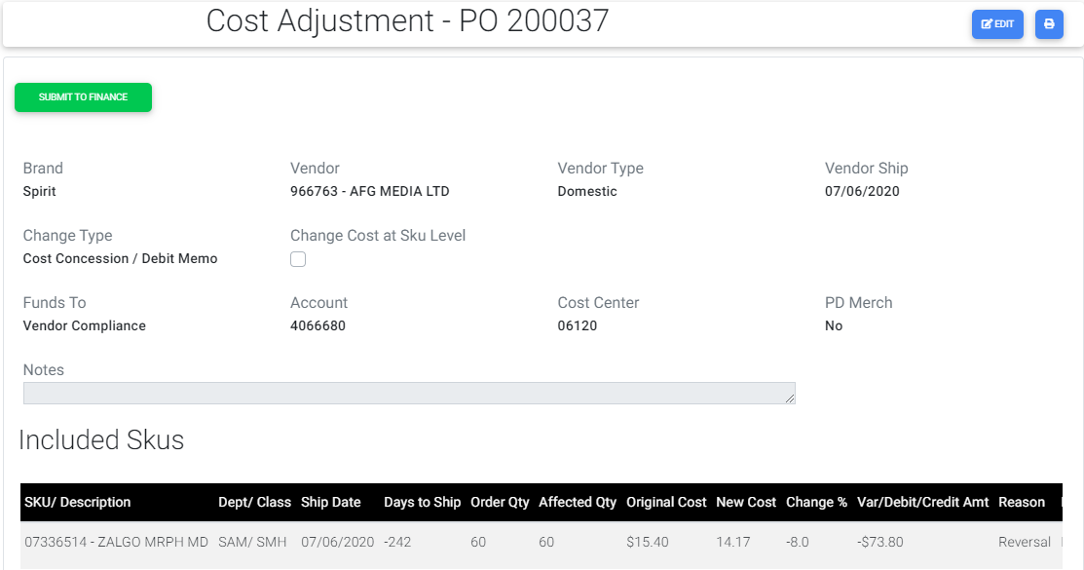

1. When a request is submitted without having attached a file then a confirmation warning message will be displayed when Submit button is clicked.
2. When Buyer creates a Cost Adjustment request and if not submitted request goes under Unsubmitted lists.

# When Buyer clicks the Submit To Finance button then the request is submitted and the workflow is created with two steps as below:

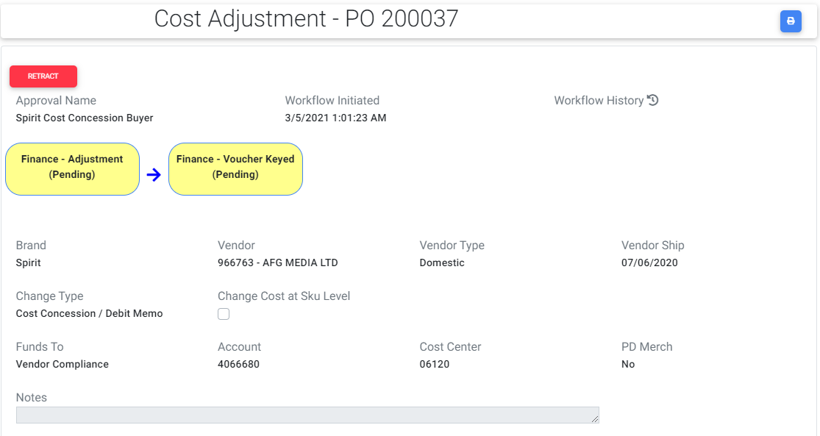

# For Buyer Retract button is visible until the request is completed by Finance. When Buyer clicks the Retract button he can submit the request again.

1. If Buyer submits the request then request moves from Unsubmitted to Incomplete lists.
2. If buyer retracts the request or Finance Rejects the request then the request goes back to Unsubmitted lists from Incomplete lists.

# For Finance role Complete Adjustment and Reject buttons are visible.

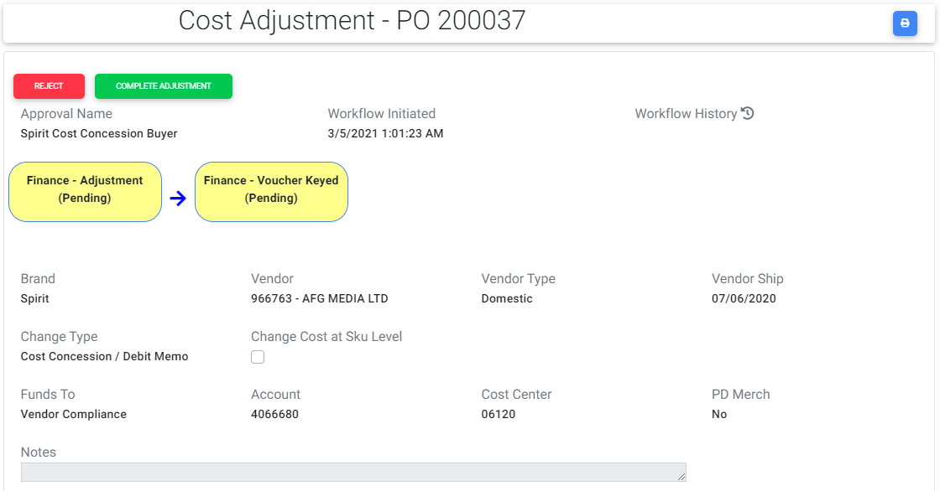

# If Finance user clicks the Reject button once again buyer needs to submit the request and workflow will be restarted again.

# If Finance user clicks the Complete button then the Finance- Adjustment step changes from Pending to Approved.

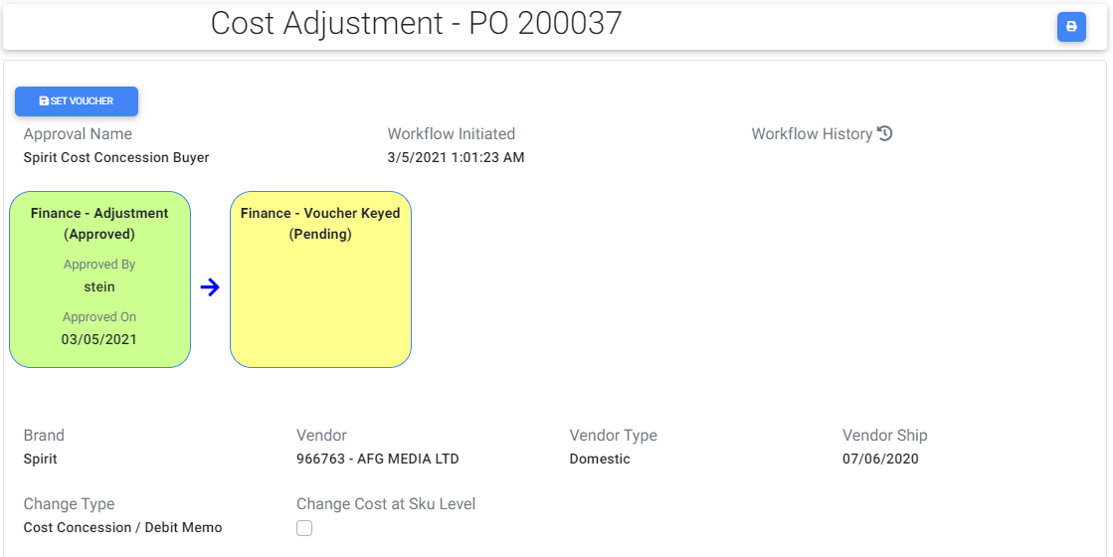

# Now Set Voucher button will be displayed and once when he clicks that button a popup will be displayed with a check box.

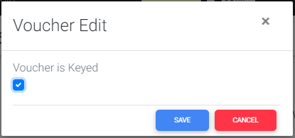

# Once finance user checks and saves it the Finance-Voucher Keyed step status changes from Pending to Approved.

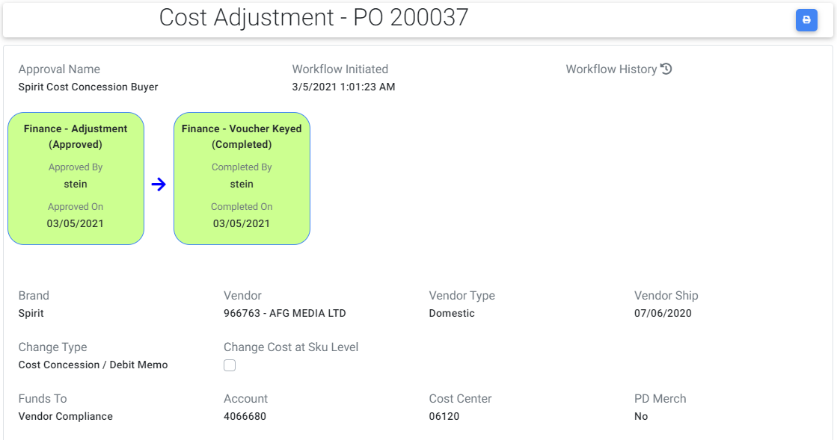

1. If Finance completes the request then the request moves from Incomplete to Completed lists.

# A print icon is visible at top right corner of cost adjustment if user clicks that icon, request will be navigated to read only screen where user can take a print of the request as per there requirements.

## 1.6.5 MerchOps:

# User is in MerchOps role and navigates to cost adjustment screen and selects change type as Cost Change, PO type can be either Domestic/Foreign and gives the desired change percent value based on selected change type for a Spirit PO, enters the data for required fields and creates a cost adjustment request. Submit To Finance button will be visible.

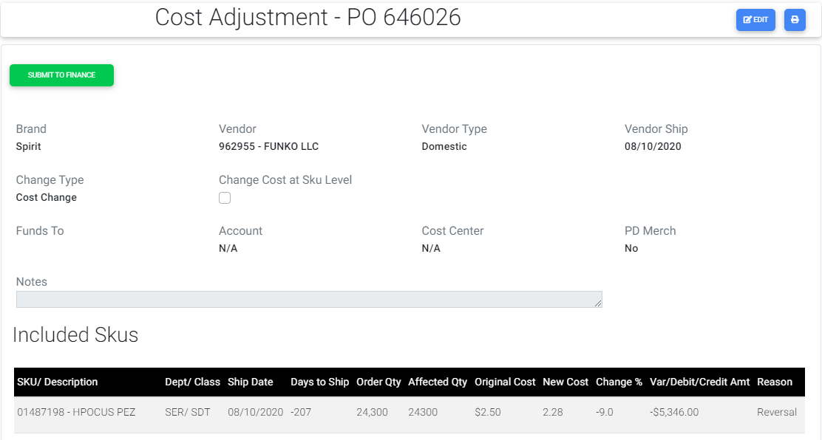

1. When a request is submitted without having attached a file then a confirmation warning message will be displayed when Submit button is clicked.
2. When MerchOps creates a Cost Adjustment request and if not submitted request goes under Unsubmitted lists.

# When MerchOps clicks the Submit To Finance button then the request is submitted and the workflow is created with one step as below:

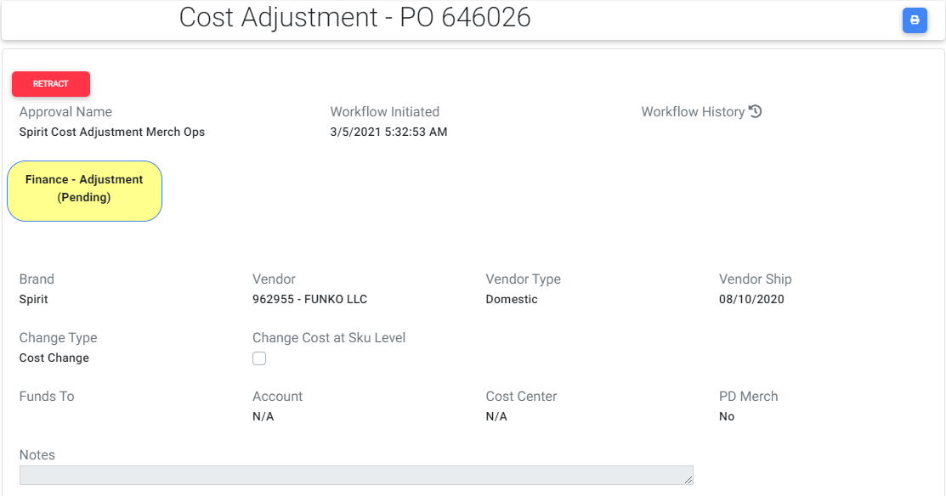

# For MerchOps Retract button is visible until the request is completed by Finance. When MerchOps clicks the Retract button he can submit the request again.

1. If MerchOps submits the request then request moves from Unsubmitted to Incomplete lists.
2. If MerchOps retracts the request or Finance Rejects the request then the request goes back to Unsubmitted lists from Incomplete lists.

# For Finance role Complete Adjustment and Reject buttons are visible.

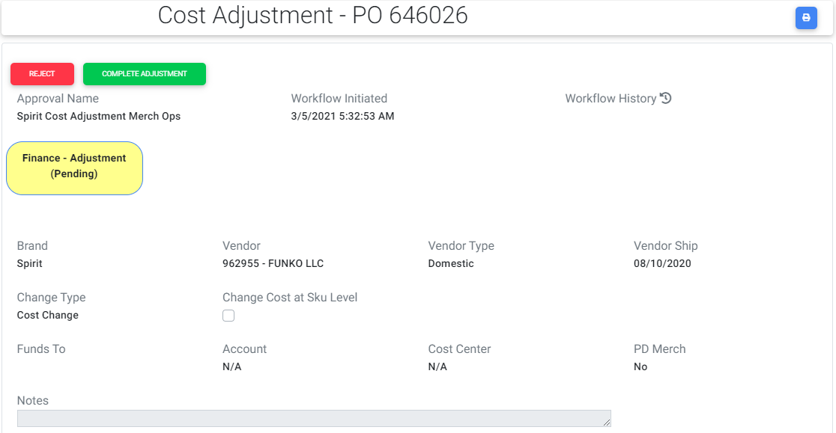

# If Finance user clicks the Reject button once again MerchOps needs to submit the request and workflow will be restarted again.

# If Finance User clicks the Complete button then the Finance- Adjustment step changes from Pending to Approved.

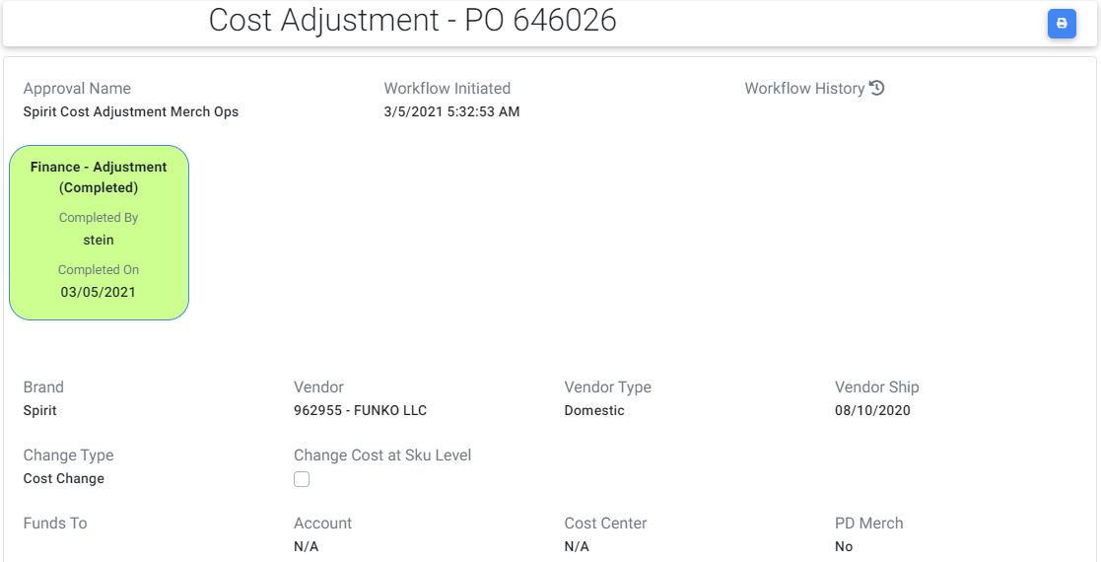

1. If Finance completes the request then the request moves from Incomplete to Completed lists.

# A print icon will be visible at top right corner once if user clicks that icon, request will be navigated to read only screen where user can take a print of the request as per there requirements.

# The same steps are repeated for Spencer worksheet.

## MerchO-CC:

# User is in MerchOps role and navigates to cost adjustment screen and selects change type as Credit/Debit memo, enters the desired change percent value based on selected change type for a Spirit PO and creates a cost adjustment request. Submit To Finance button will be visible.

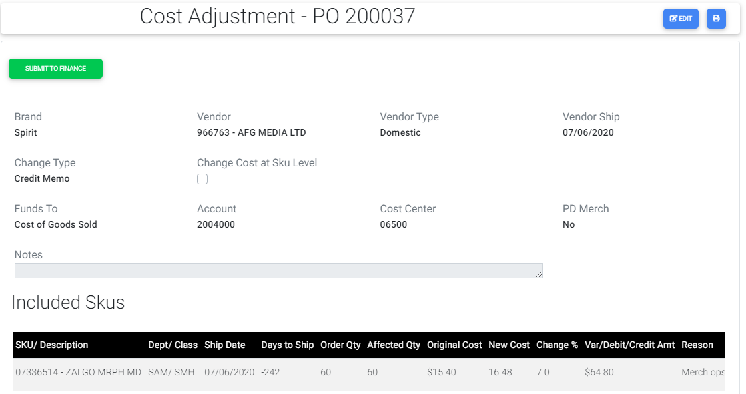

1. When a request is submitted without having attached a file then a confirmation warning message will be displayed when Submit button is clicked.
2. When MerchOps creates a Cost Adjustment request and if not submitted request goes under Unsubmitted lists.

# When MerchOps clicks the Submit To Finance button then the request is submitted and the workflow is created with two steps as below:

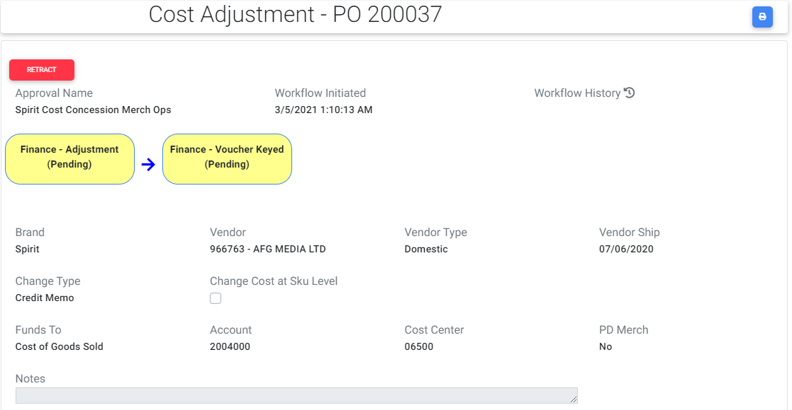

# For Merchops Retract button is visible until the request is completed by Finance. When MerchOps clicks the Retract button he can submit the request again.

1. If MerchOps submits the request then request moves from Unsubmitted to Incomplete lists.
2. If buyer retracts the request or Finance Rejects the request then the request goes back to Unsubmitted lists from Incomplete lists.

# For Finance role Complete Adjustment and Reject buttons are visible.

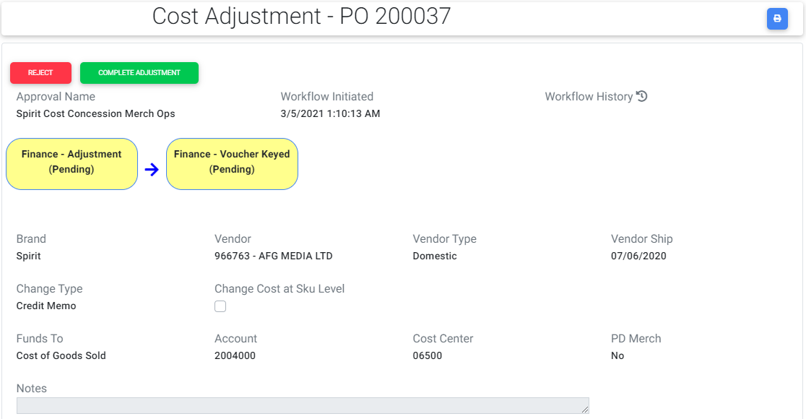

# If Finance user clicks the Reject button once again MerchOps user needs to submit the request and workflow will be restarted again.

# If MerchOps user clicks the Complete button then the Finance- Adjustment step changes from Pending to Approved.

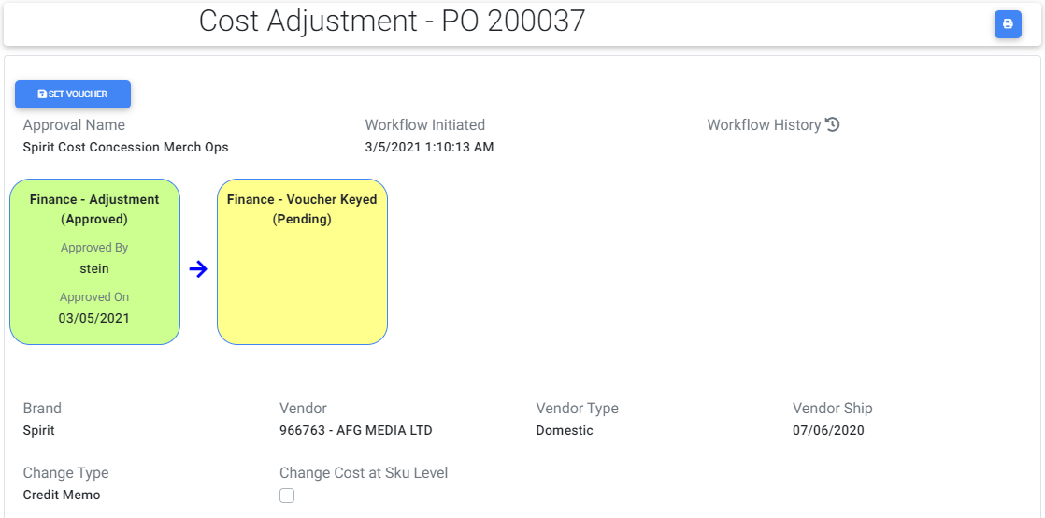

# Now Set Voucher button will be displayed and once when he clicks that button a popup will be displayed with a check box.

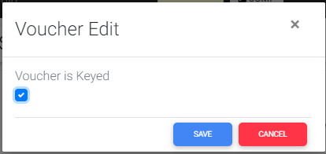

# If finance user checks and saves it the Finance-Voucher Keyed step status changes from Pending to Approved.

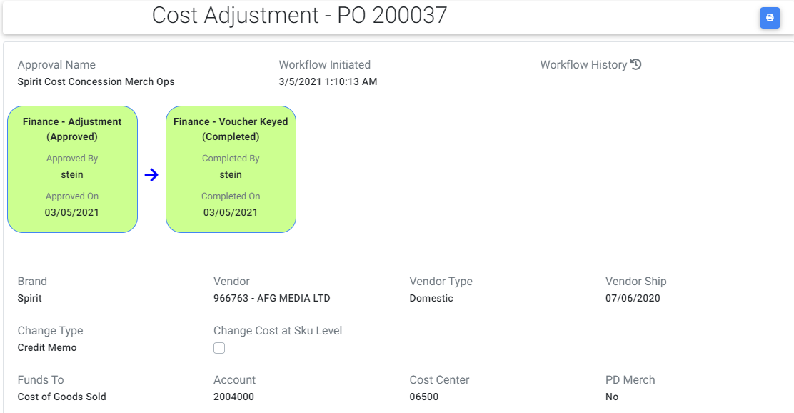

1. If Finance completes the request then the request moves from Incomplete to Completed lists.

# A print icon is visible at top right corner of cost adjustment if user clicks that icon, request will be navigated to read only screen where they can take a print of the request as per there requirements.

# The same steps are repeated for Spencer worksheet.

## MerchO-IC:

# User is in MerchOps role and navigates to cost adjustment screen and selects change type as Credit/Debit memo, enters the desired change percent value based on selected change type, PO type is Foreign and Intended Cost Change reason is selected from Reason drop down for a Spirit PO and creates a cost adjustment request. Submit To Finance button will be visible.

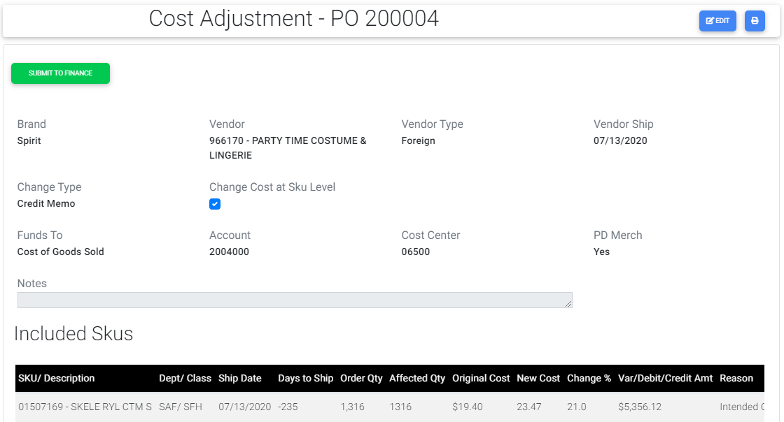

# For MerchOps Retract button is visible until the request is completed by Finance. When MerchOps clicks the Retract button he can submit the request again.

1. When MerchOps creates a Cost Adjustment request and if not submitted request goes under Unsubmitted lists.

# When MerchOps clicks the Submit To Finance button then the request is submitted and the workflow is generated with three steps as below:

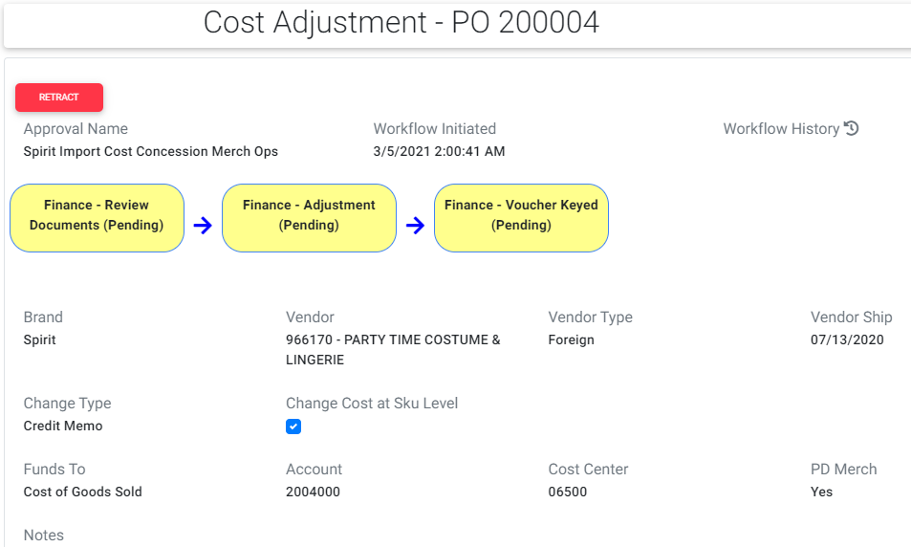

1. If MerchOps submits the request then request moves from Unsubmitted to Incomplete lists.
2. If MerchOps retracts the request or Finance Rejects the request then the request goes back to Unsubmitted lists from Incomplete lists.

# Now for Finance Review Documents role Customs Override, Reject button and Review Documents button are visible.

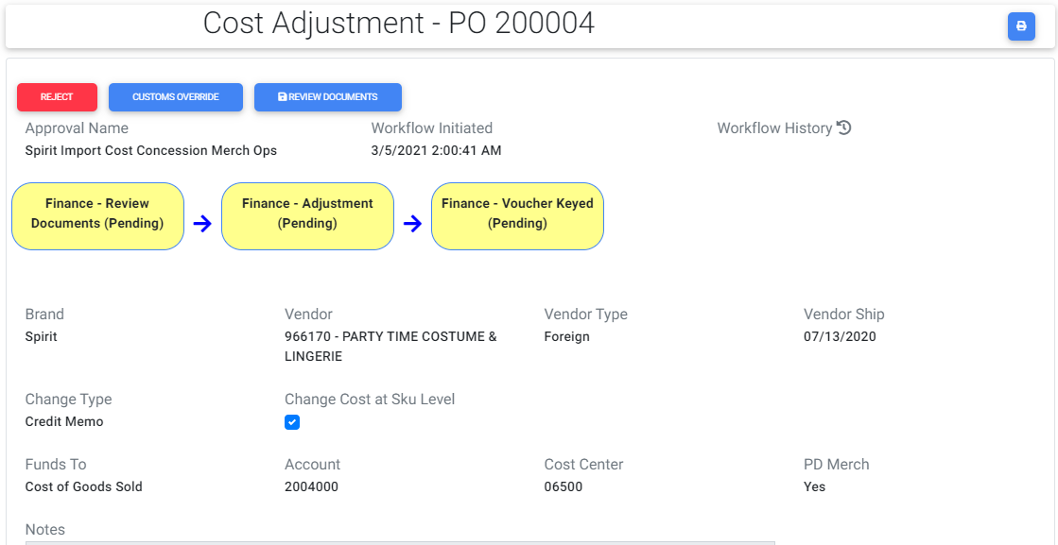

# Once user clicks the Reject button the request will be rejected and the buyer should submit the request.

# If user clicks Review documents button a popup will be displayed with a check box and if user checks it and saves it then Finance Review Documents step status changes from Pending to Approved.

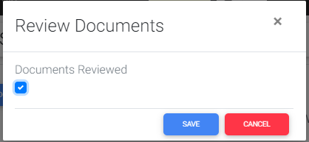

# If user clicks customs override button then the change type becomes cost change and check box value changes to unchecked and the request gets completed removing the Finance Voucher keyed step.

# If Finance review gets approved then Complete Adjustment and Reject buttons are visible.

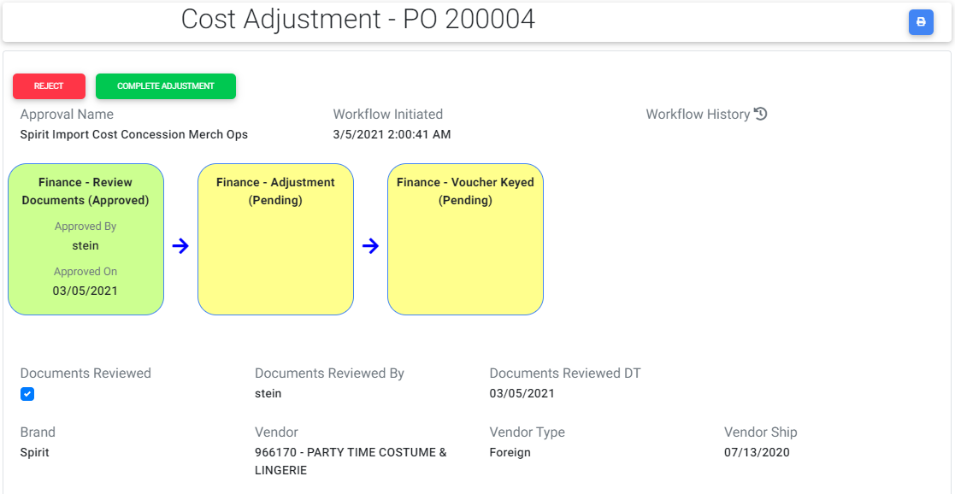

# Once Finance user clicks the Reject button once again buyer needs to submit the request and workflow will be restarted again.

# If Finance user clicks the Complete button then the Finance- Adjustment step changes from Pending to Approved.

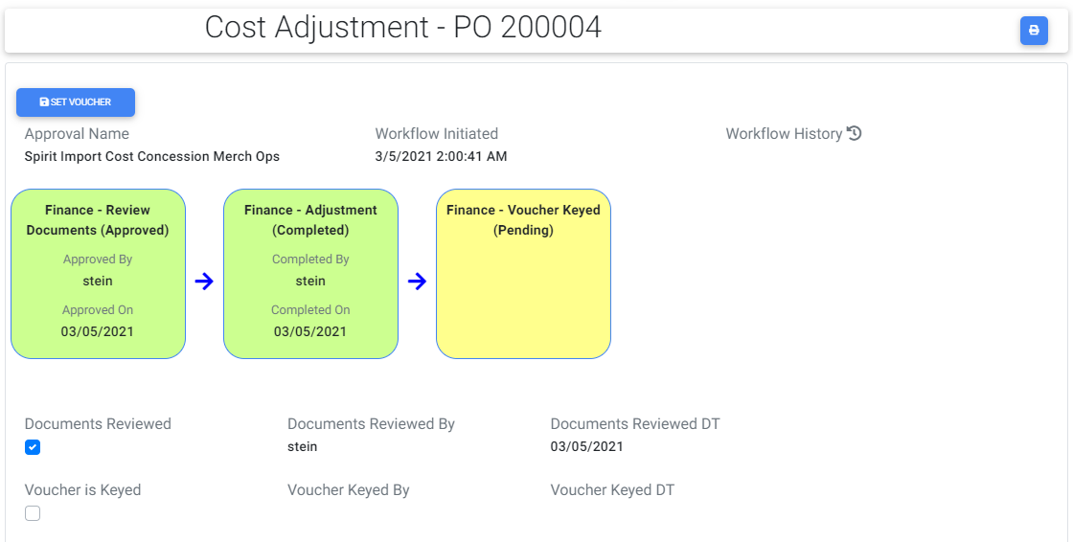

# Now Set Voucher button will be displayed and once when he clicks that button a popup will be displayed with a check box.

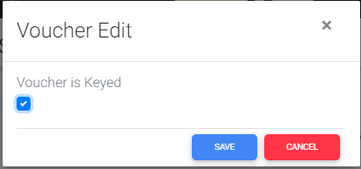

# Once finance user checks and saves it the Finance-Voucher Keyed step status changes from Pending to Approved.

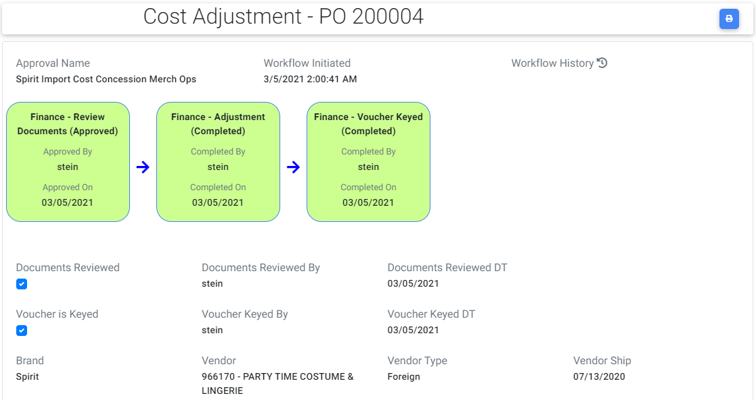

1. If Finance completes the request then the request moves from Incomplete to Completed lists.

# A print icon is visible at top right corner of cost adjustment if user clicks that icon, request will be navigated to read only screen where user can take a print of the request as per there requirements.

## BuyerST-IC:

# User is in Buyer role and navigates to cost adjustment screen and selects change type as Credit/Debit memo, enters the change percent value within threshold range (-10 to 10), PO type is Foreign and Intended Cost Change reason is selected from Reason drop down for a Spirit PO and creates a cost adjustment request. Submit To Finance button will be visible.

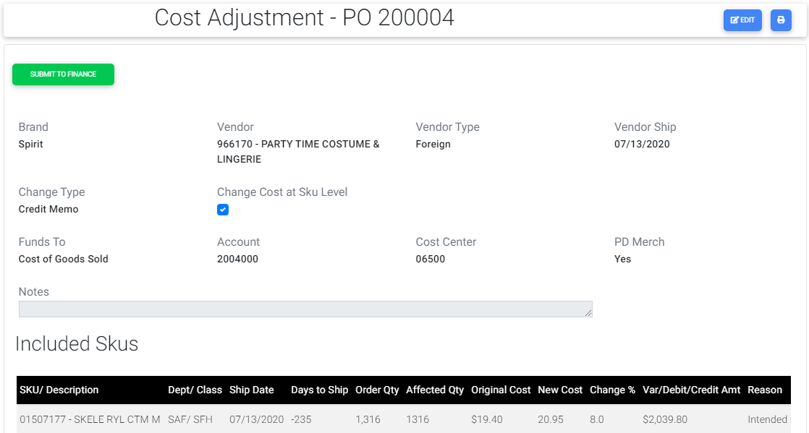

# For Buyer Retract button is visible until the request is completed by Finance. When Buyer clicks the Retract button he can submit the request again.

1. When Buyer creates a Cost Adjustment request and if not submitted request goes under Unsubmitted lists.

# When Buyer clicks the Submit To Finance button then the request is submitted and the workflow is created with two steps as below:

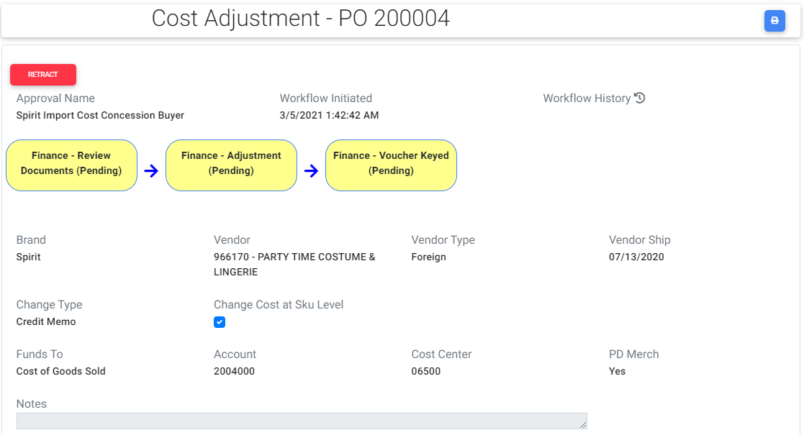

1. If Buyer submits the request then request moves from Unsubmitted to Incomplete lists.
2. If buyer retracts the request or Finance Rejects the request then the request goes back to Unsubmitted lists from Incomplete lists.

# Now for Finance Review Documents role Customs Override, Reject button and Review Documents button are visible.

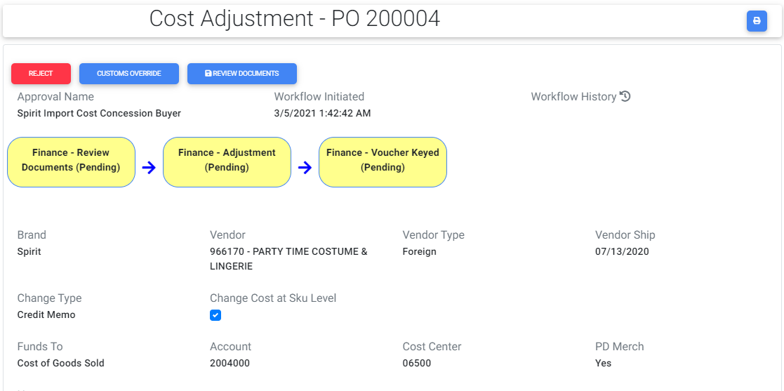

# Once user clicks the Reject button the request will be rejected and the buyer should submit the request.

# If user clicks Review documents button a popup will be displayed with a check box and if user checks it and saves it then Finance Review Documents step status changes from Pending to Approved.

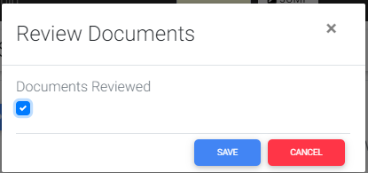

# If user clicks customs override button then the change type becomes cost change and check box value changes to unchecked and the request gets completed removing the Finance Voucher keyed step.

# If Finance review gets approved then Complete Adjustment and Reject buttons are visible.

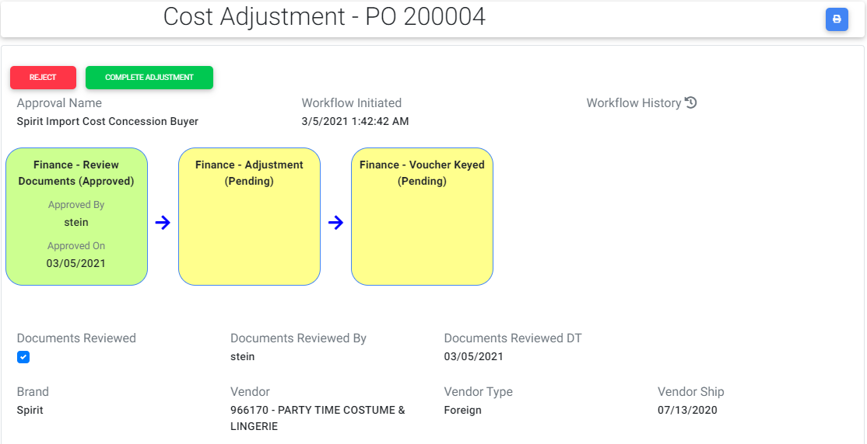

# Once Finance user clicks the Reject button once again buyer needs to submit the request and workflow will be restarted again.

# If user clicks the Complete button then the Finance- Adjustment step changes from Pending to Approved.

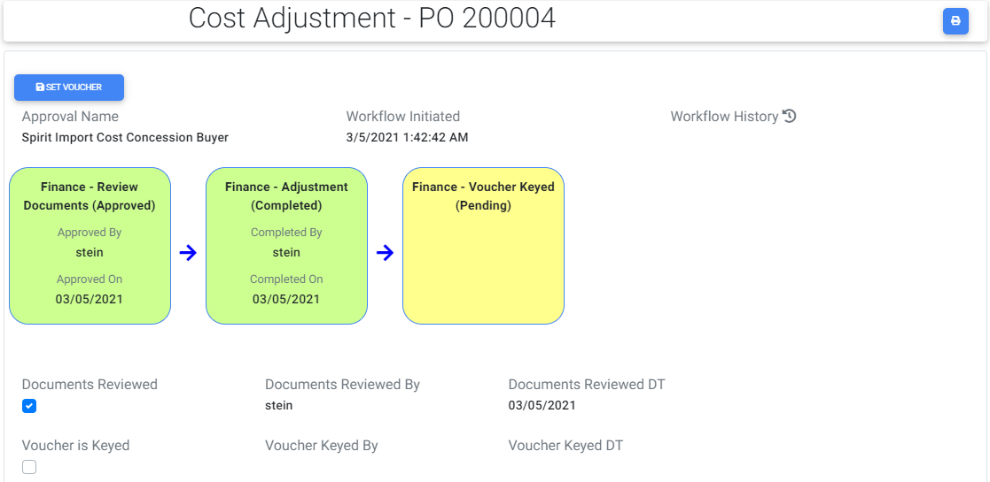

# Now Set Voucher button will be displayed and once when he clicks that button a popup will be displayed with a check box.

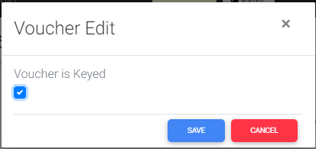

# Once finance user checks and saves it the Finance-Voucher Keyed step status changes from Pending to Approved.

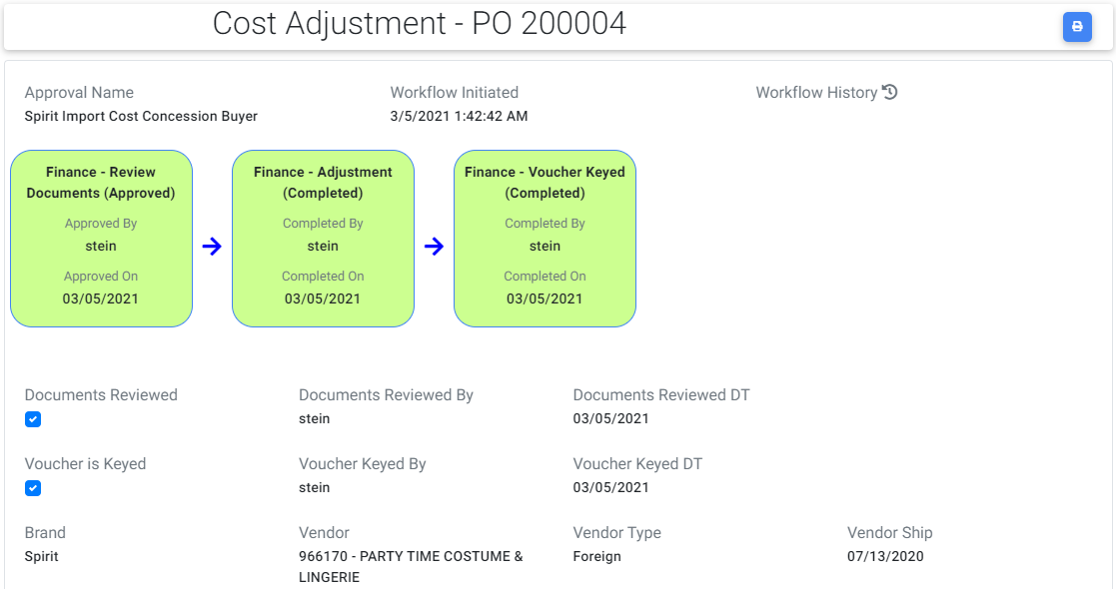

1. If Finance completes the request then the request moves from Incomplete to Completed lists.

# A print icon is visible at top right corner of cost adjustment if user clicks that icon, request will be navigated to read only screen where user can take a print of the request as per there requirements.

## Buyer-IC:

# User is in Buyer role and navigates to cost adjustment screen and selects change type as Credit/Debit memo, enters the desired change percent value based on selected change type, PO type is Foreign and reason Intended Cost Change is selected for a Spirit PO and creates a cost adjustment request. Submit To Approval button will be visible.

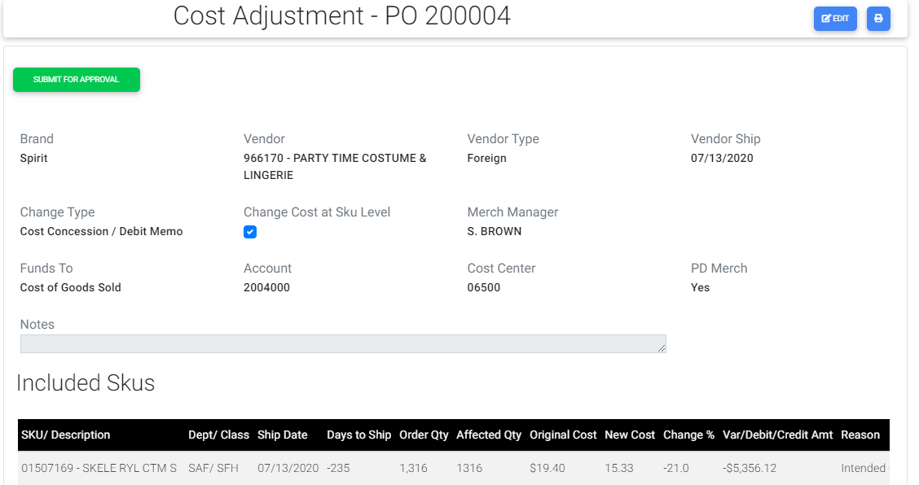

# For Buyer Retract button is visible until the request is completed by Finance. When Buyer clicks the Retract button he can submit the request again.

3. When Buyer creates a Cost Adjustment request and if not submitted request goes under Unsubmitted lists.

# 4. When buyer clicks the Submit To Approval button then the request is submitted and the workflow is created with four steps as below:

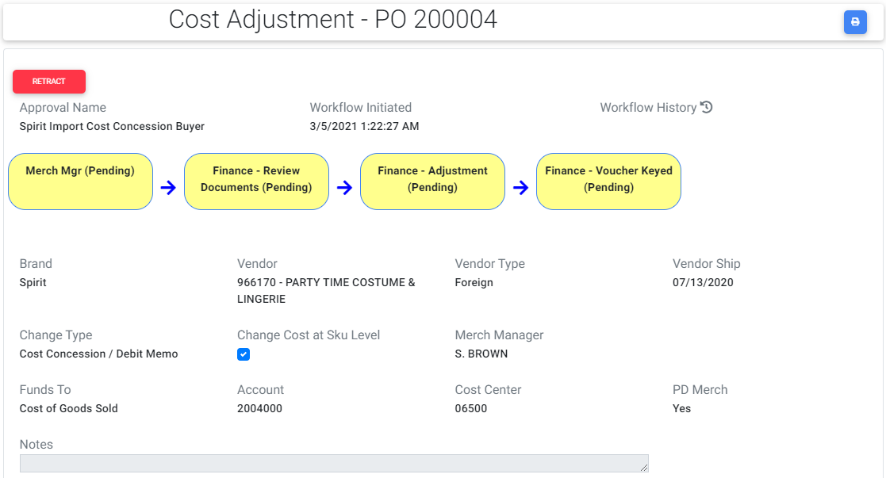

# 5. Now for the Merch Manager role Approve and Reject buttons are visible.

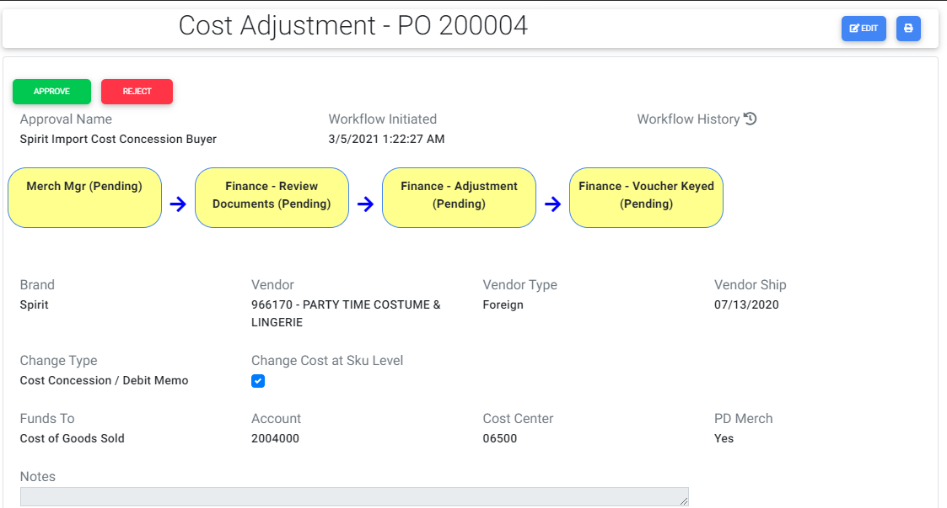

# 6.Once Merch Manger approves the request Merch Manger’s step status changes from Pending to Approved.

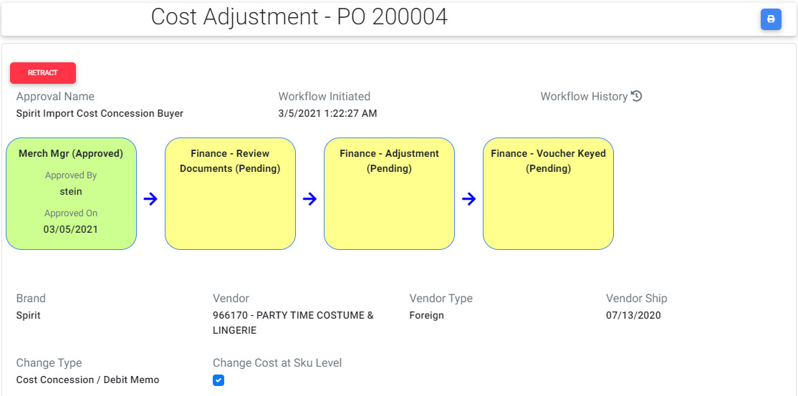

# Incase if Merch Manager clicks Reject button the request will be rejected and again the buyer should submit the request.

# Retract button is visible for Merch Manger until the request is completed by Finance.

# If Merch Manager clicks the Retract button once again Approve and Reject buttons are visible.

1. If Buyer submits the request then request moves from Unsubmitted to Incomplete lists.
2. If buyer retracts the request or Merch Manager / Finance Rejects the request then the request goes back to Unsubmitted lists from Incomplete lists.

# Now for Finance Review Documents role Customs Override, Reject button and Review Documents button are visible.

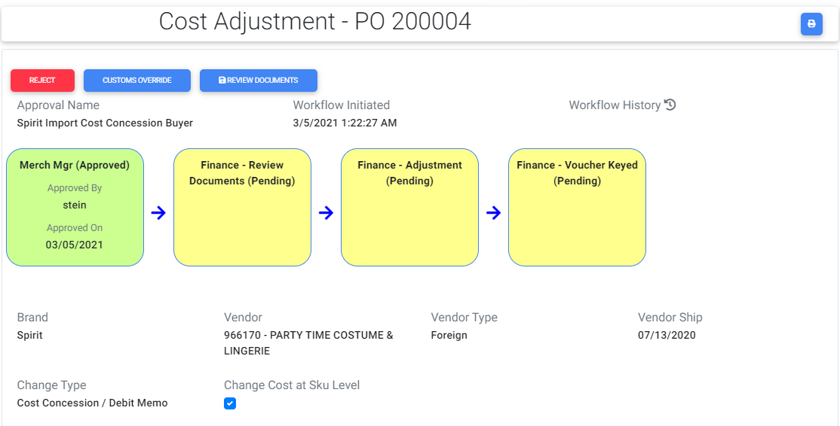

# Once user clicks the Reject button the request will be rejected and the buyer should submit the request.

# If user clicks Review documents button a popup will be displayed with a check box and if user checks it and saves it then Finance Review Documents step status changes from Pending to Approved.

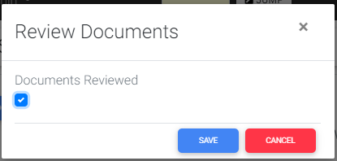

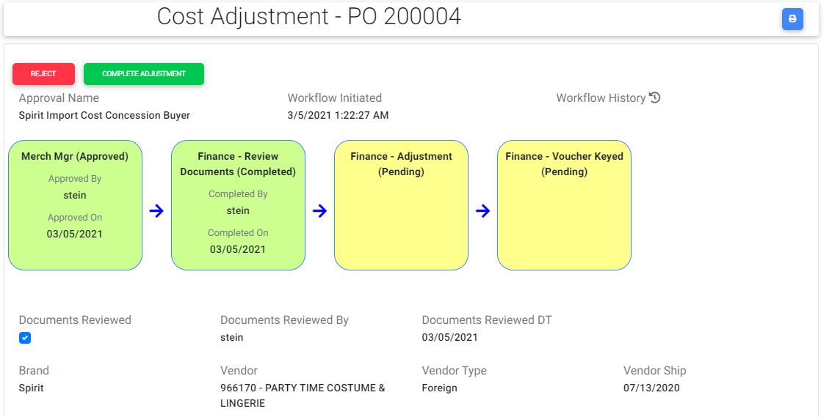

# If user clicks customs override button then the change type becomes cost change and check box value changes to unchecked and the request gets completed removing the Finance Voucher keyed step.

# If Finance review gets approved then Complete Adjustment and Reject buttons are visible.

# Once Finance user clicks the Reject button once again buyer needs to submit the request and workflow will be restarted again.

# If user clicks the Complete button then the Finance- Adjustment step changes from Pending to Approved.

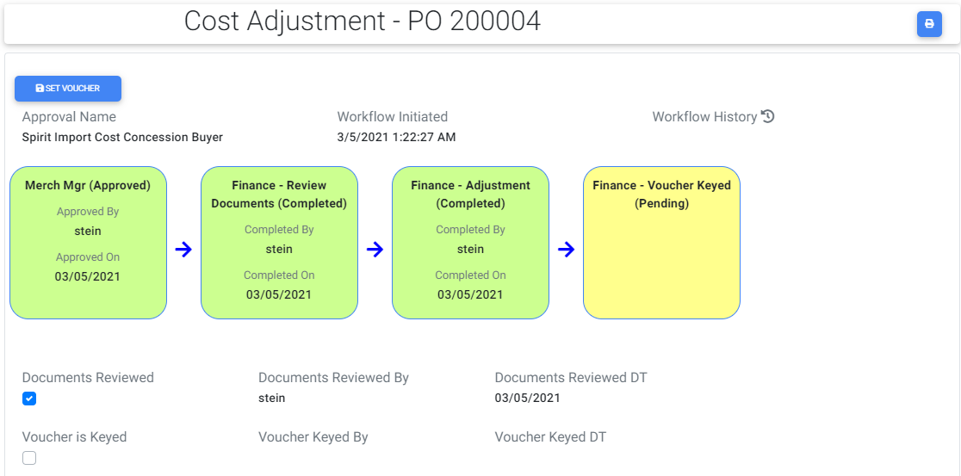

# Now Set Voucher button will be displayed and once when he clicks that button a popup will be displayed with a check box.



# If finance user checks and saves it the Finance-Voucher Keyed step status changes from Pending to Approved.

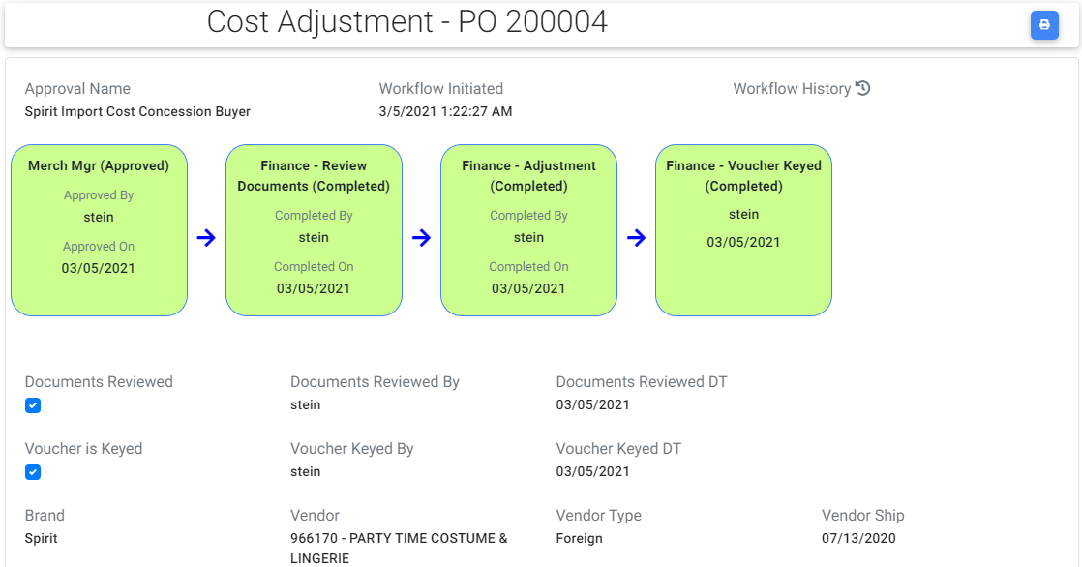

1. If Finance completes the request then the request moves from Incomplete to Completed lists.

# A print icon is visible at top right corner of cost adjustment if user clicks that icon, request will be navigated to read only screen where user can take a print of the request.

**1.70 Buyer-VC:**

# User is in Buyer role and navigates to cost adjustment screen and selects Change type as Debit memo, Funds To as Vendor Compliance. PO type is Domestic and change percent value other than threshold ie (other than -10 to +10)(negative value). Since change percent is not in the range of threshold Merch Manger drop down will be visible and user enters the required data and then creates the request for Spirit PO. Submit For Approval button will be visible.

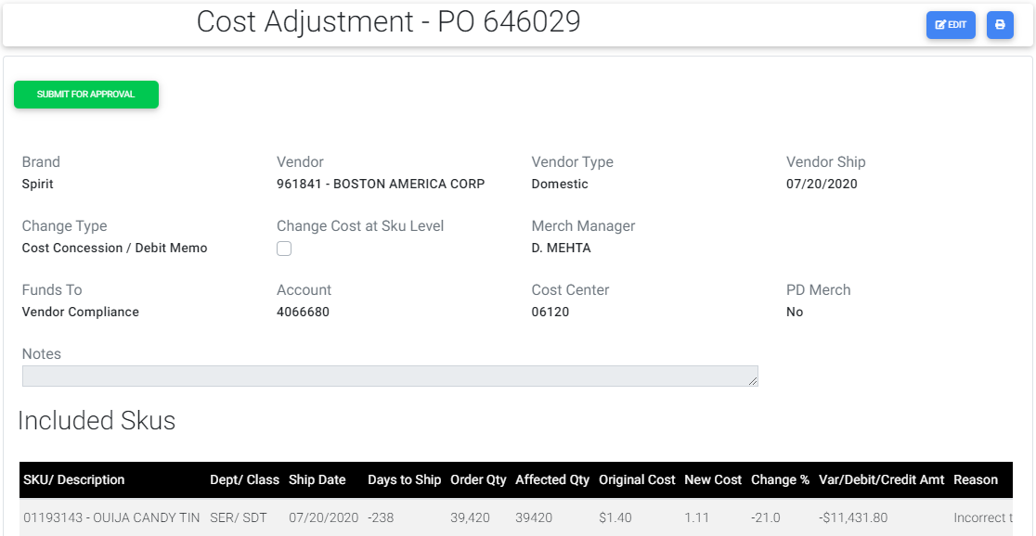

1. When a request is submitted without having attached a file then a confirmation warning message will be displayed when Submit button is clicked.
2. When Buyer creates a Cost Adjustment request and if not submitted request goes under Unsubmitted lists.
3. When Buyer clicks the Submit For Approval button then the request is submitted and the workflow is generated three steps as below.

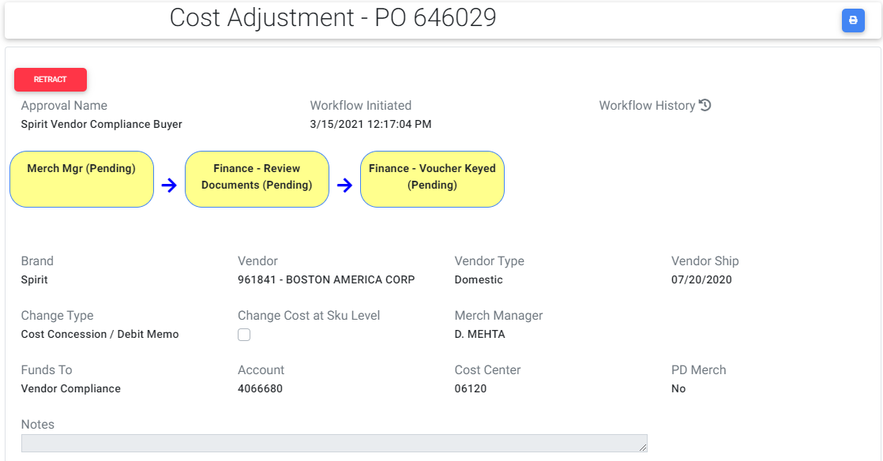

1. If Buyer submits the request then request moves from Unsubmitted to Incomplete lists.
2. For Buyer Retract button is visible until request is completed by Finance. When Buyer clicks the Retract button buyer can submit the request again.
3. Now for the Merch Manager role Approve and Reject buttons are visible.

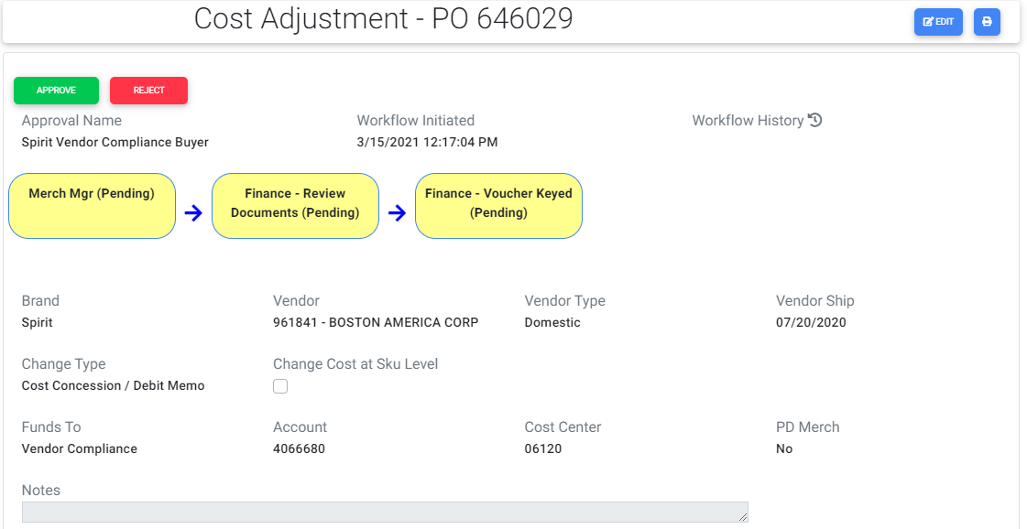

1. If Merch Manager approves the request the Merch Manger’s step status changes from Pending to Approved.

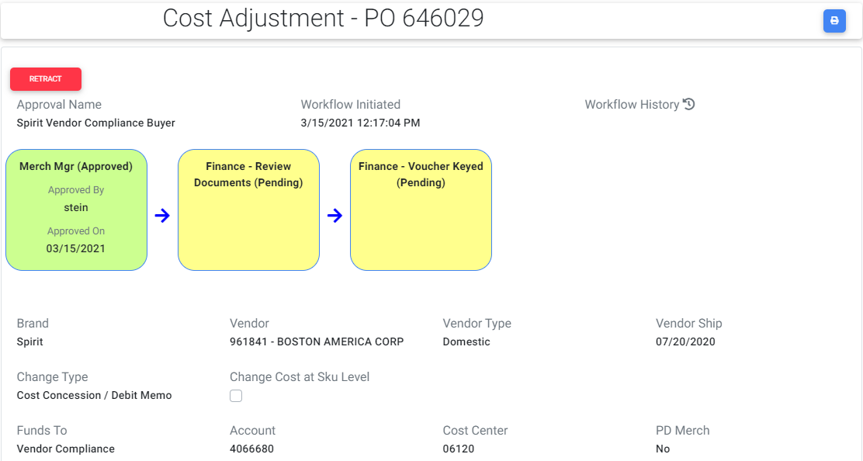

1. Incase if Merch Manager clicks Reject button the request will be rejected and again the buyer should submit the request.
2. Retract button is visible for Merch Manger until the request is completed by Finance.
3. If Merch Manager clicks the Retract button once again Approve and Reject buttons are visible.
4. If buyer retracts the request or Merch Manager / Finance Rejects the request then the request goes back to Unsubmitted lists from Incomplete lists.
5. Now for Finance documents role Reject and Review Document buttons are visible.

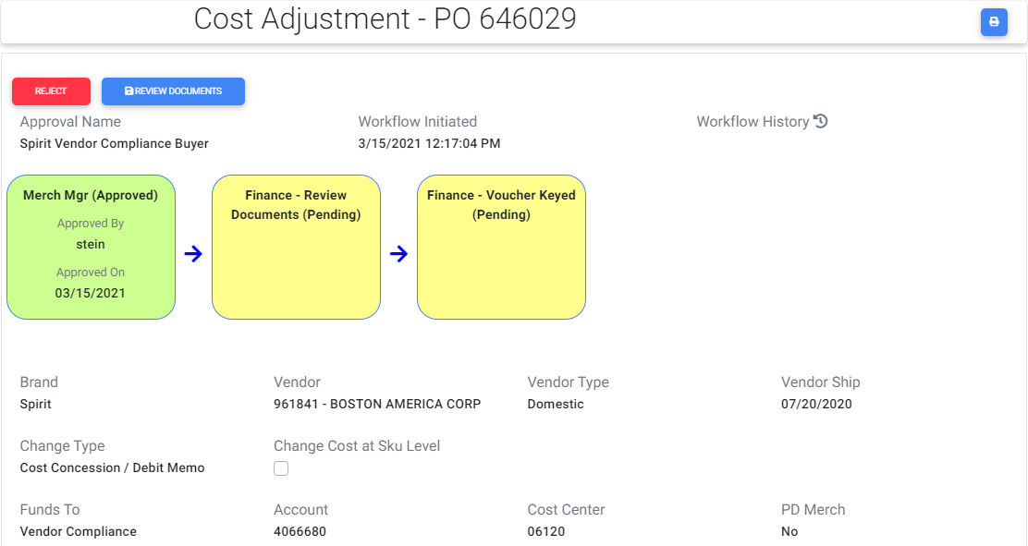

# Once user clicks the Reject button the request will be rejected and the buyer should submit the request.

# If user clicks Review documents button a popup will be displayed with a check box and if user checks it and saves it then Finance Review Documents step status changes from Pending to Approved.

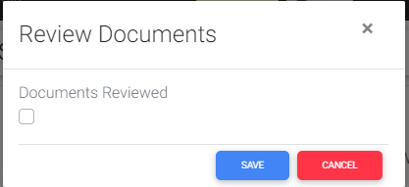

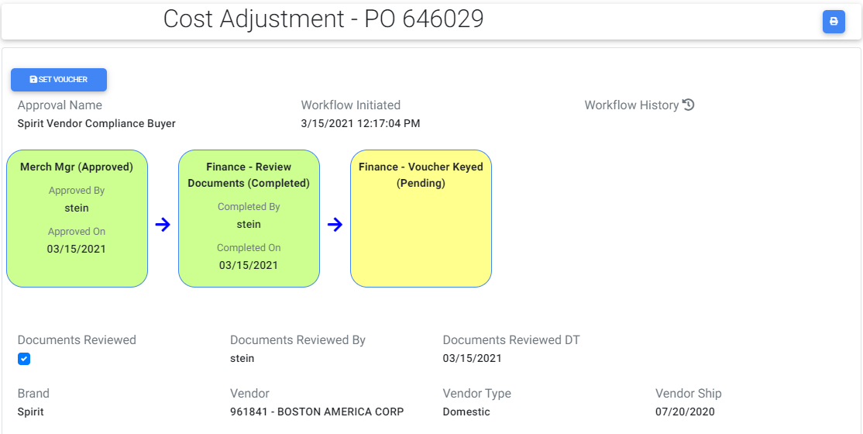

1. If Finance user completes the request then the request moves from Incomplete to Completed lists.
2. Now Set Voucher button will be displayed and once when he clicks that button a popup will be displayed with a check box.

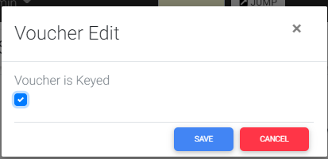

1. If finance user checks and saves it the Finance-Voucher Keyed step status changes from Pending to Approved.
2. A print icon is visible at top right corner of cost adjustment if user clicks that icon, request will be navigated to read only screen where user can take a print of the request as per there requirements.
3. The same steps are repeated for Spencer worksheet and the only difference is there is no threshold value and by default Merch Manager field is visible and it is a required field.

**1.71 Buyer ST-VC:**

# User is in Buyer role and navigates to cost adjustment screen and selects Change type as Debit memo, Funds To as Vendor Compliance and change percent within threshold for a Spirit PO(negative value since Debit). Since change percent is within threshold Merch Manger drop down will not be visible and adjustment request skips the Merch Managers approval and directly goes to Finance. User enters the require data and creates a Cost Adjustment request. Submit To Finance button will be visible.

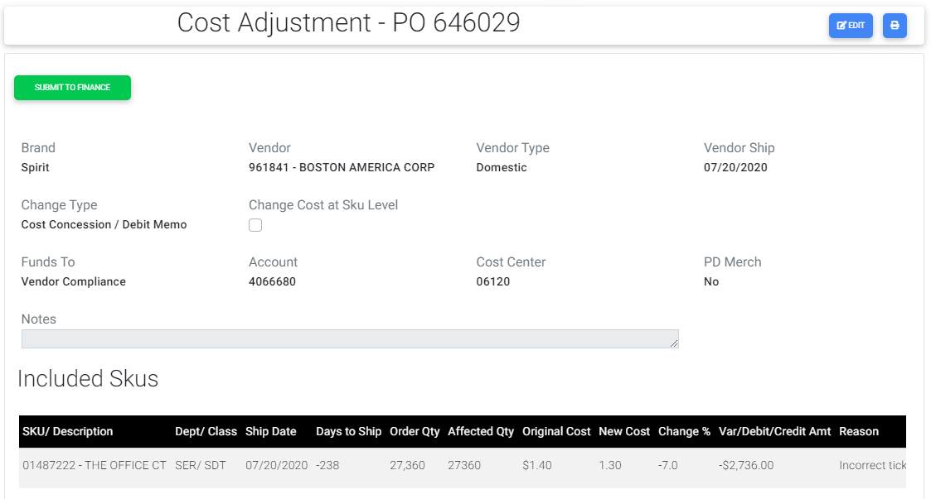

# For Buyer Retract button is visible until the request is completed by Finance. When Buyer clicks the Retract button he can submit the request again.

1. When Buyer creates a Cost Adjustment request and if not submitted request goes under Unsubmitted lists.

# When Buyer clicks the Submit To Finance button then the request is submitted and the workflow is created with two steps as below:

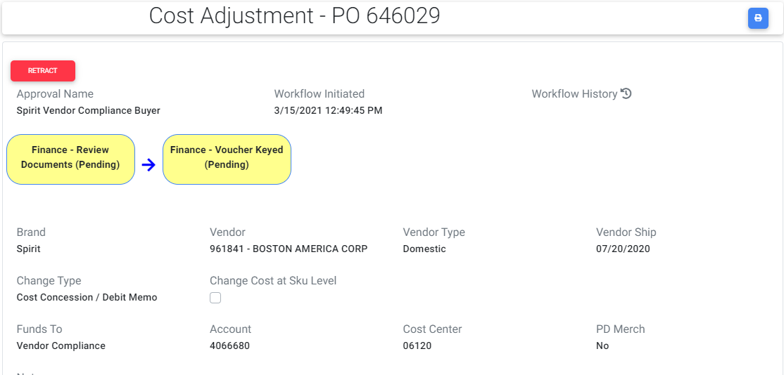

1. If Buyer submits the request then request moves from Unsubmitted to Incomplete lists.
2. If buyer retracts the request or Finance Rejects the request then the request goes back to Unsubmitted lists from Incomplete lists.

# Now for Finance Review Documents role Reject button and Review Documents button are visible.

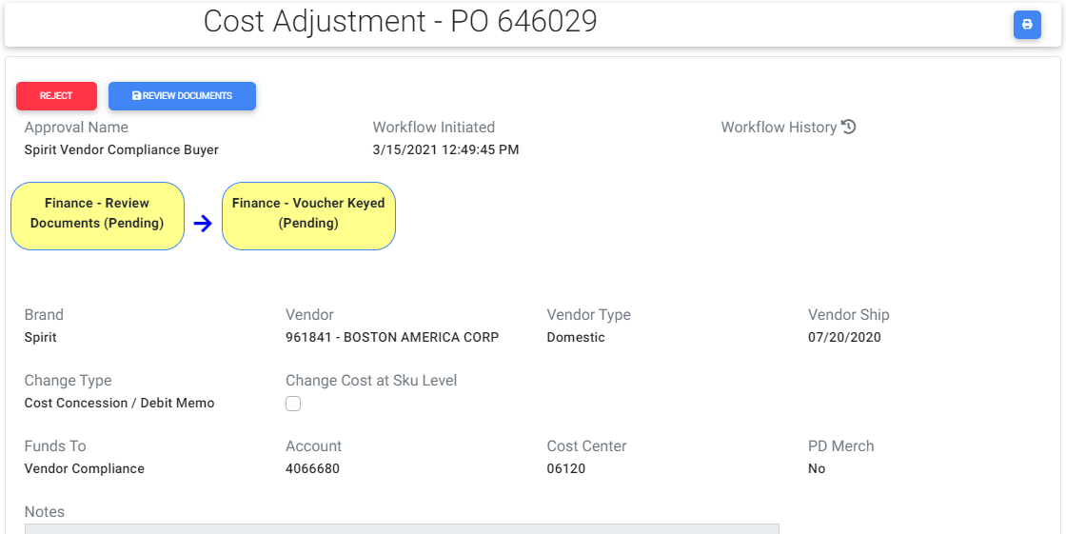

# Once user clicks the Reject button the request will be rejected and the buyer should submit the request.

# If user clicks Review documents button a popup will be displayed with a check box and if user checks it and saves it then Finance Review Documents step status changes from Pending to Approved.

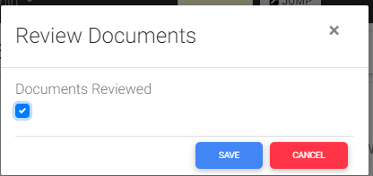

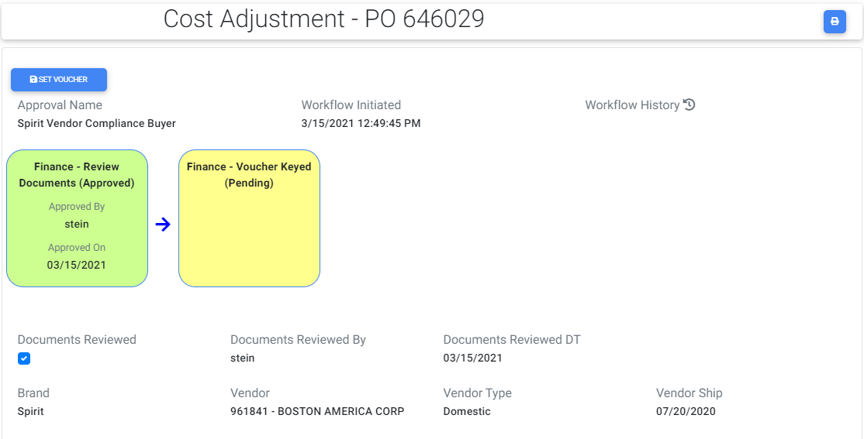

1. If Finance user completes the request then the request moves from Incomplete to Completed lists.
2. Now Set Voucher button will be displayed and once when he clicks that button a popup will be displayed with a check box.

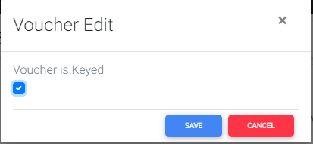

1. If finance user checks and saves it the Finance-Voucher Keyed step status changes from Pending to Approved.

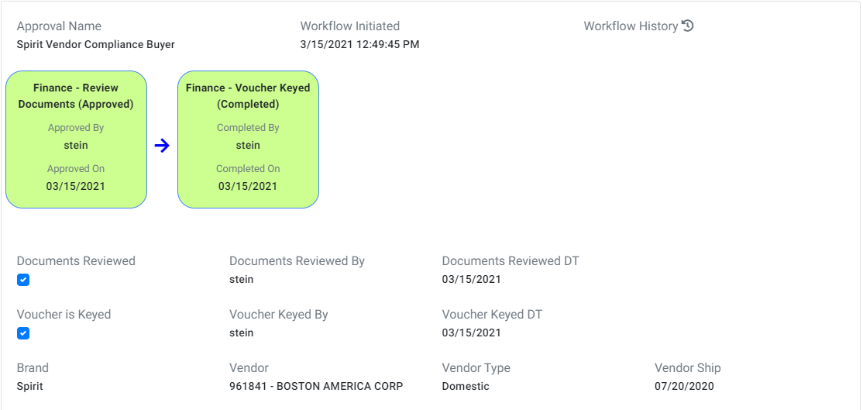

1. A print icon is visible at top right corner of cost adjustment if user clicks that icon, request will be navigated to read only screen where user can take a print of the request as per there requirements.

**1.72 MerchO-VC:**

# User is in MerchOps role and navigates to cost adjustment screen and selects change type as Debit memo, Funds To as Vendor Compliance and enters the desired change percent value based on selected change type for a Spirit PO and creates a cost adjustment request. Submit To Finance button will be visible.

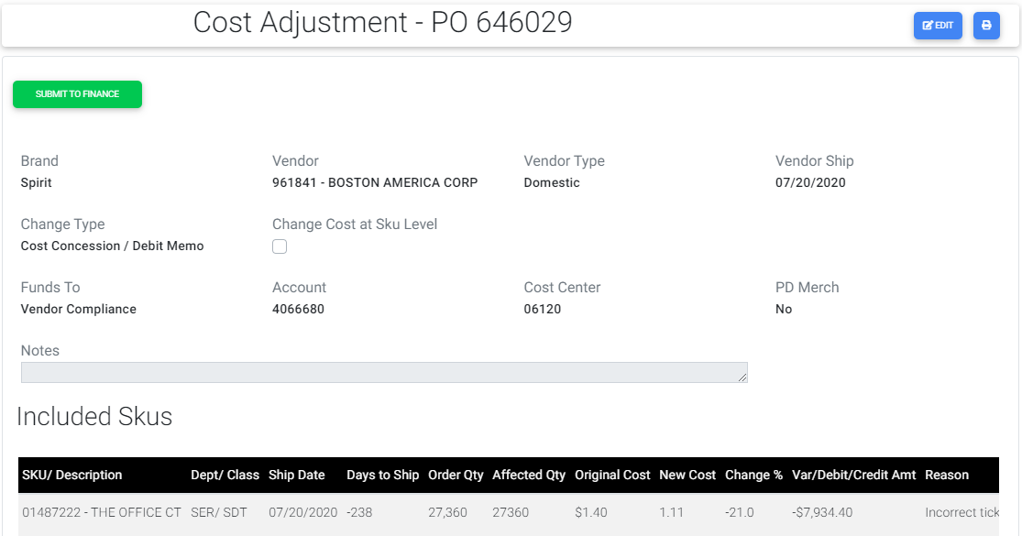

1. When a request is submitted without having attached a file then a confirmation warning message will be displayed when Submit button is clicked.
2. When MerchOps creates a Cost Adjustment request and if not submitted request goes under Unsubmitted lists.

# When MerchOps clicks the Submit To Finance button then the request is submitted and the workflow is created with two steps as below:

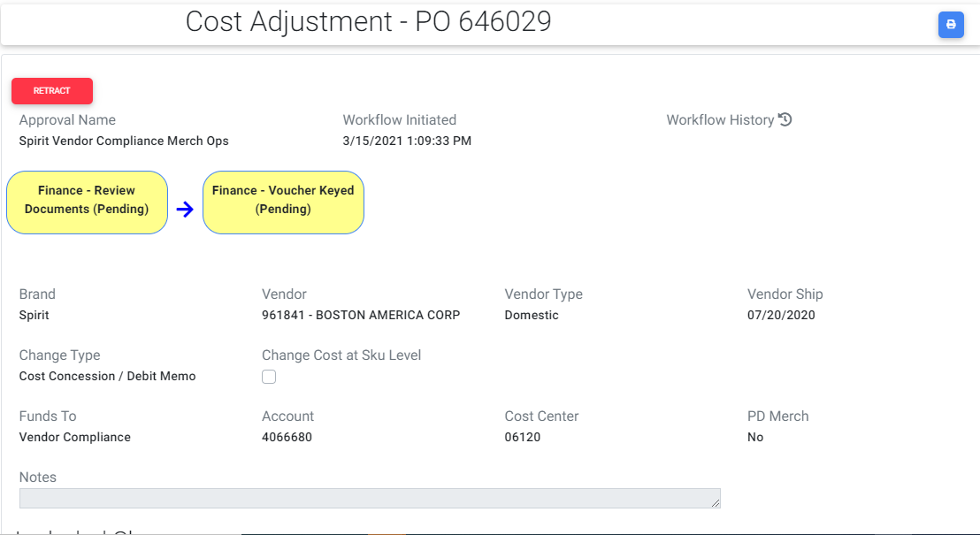

# For MerchOps Retract button is visible until the request is completed by Finance. When MerchOps clicks the Retract button he can submit the request again.

1. If MerchOps submits the request then request moves from Unsubmitted to Incomplete lists.
2. If buyer retracts the request or Finance Rejects the request then the request goes back to Unsubmitted lists from Incomplete lists.

# Now for Finance Review Documents role Reject button and Review Documents button are visible.

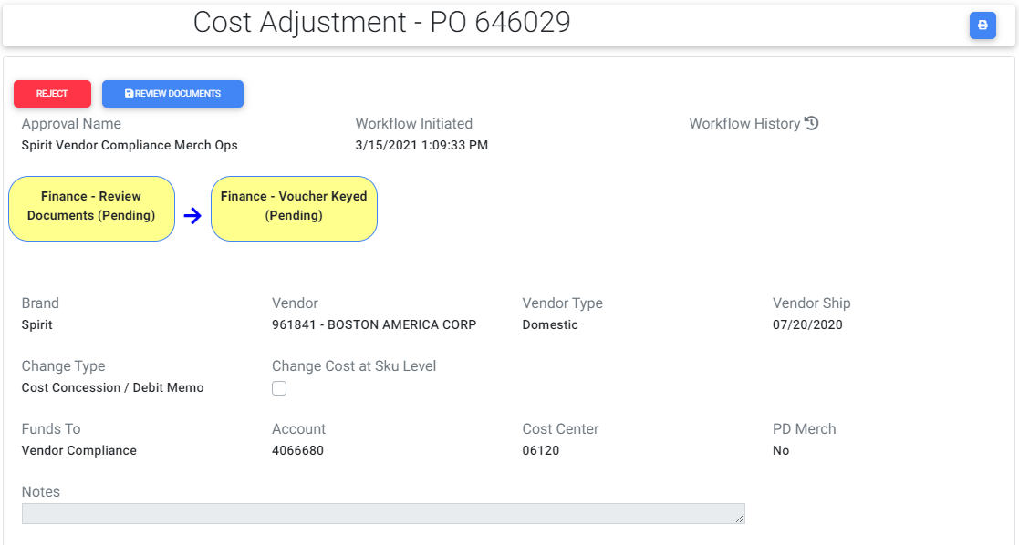

# Once user clicks the Reject button the request will be rejected and the buyer should submit the request.

# If user clicks Review documents button a popup will be displayed with a check box and if user checks it and saves it then Finance Review Documents step status changes from Pending to Approved.



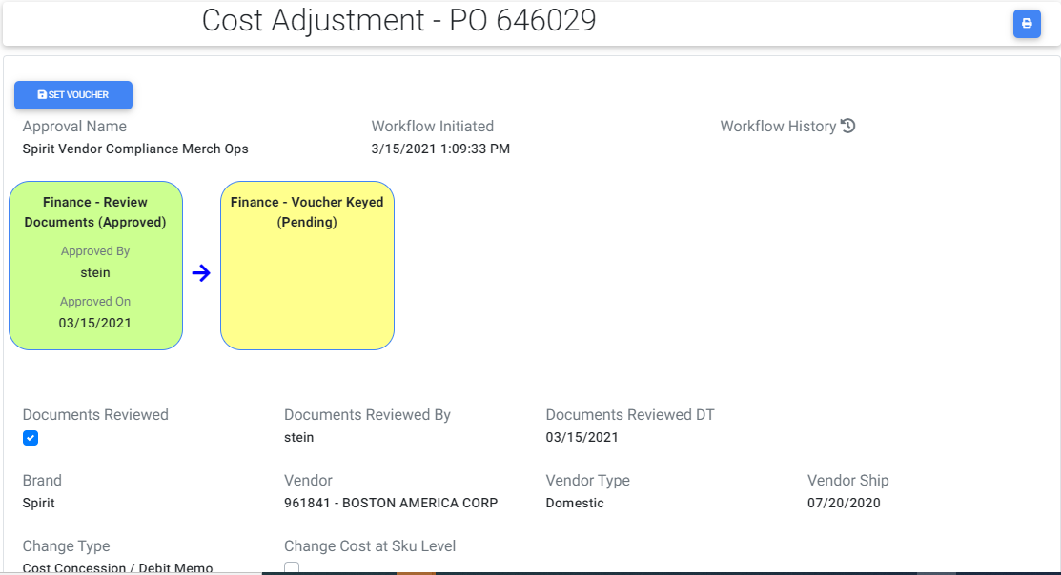

# Now Set Voucher button will be displayed and once when he clicks that button a popup will be displayed with a check box.



1. If finance user checks and saves it the Finance-Voucher Keyed step status changes from Pending to Approved.

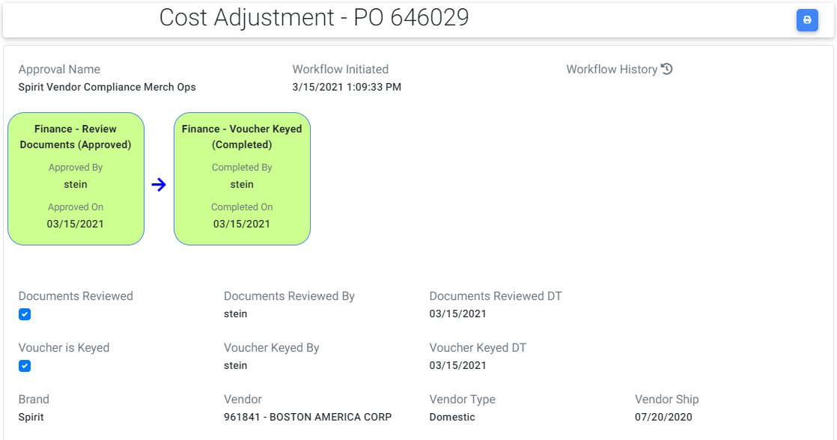

1. A print icon is visible at top right corner of cost adjustment if user clicks that icon, request will be navigated to read only screen where user can take a print of the request as per there requirements.
2. The same steps are repeated for Spencer worksheet and the only difference is there is no threshold value and by default Merch Manager field is visible and it is a required field.

## 1.8 Cost Adjustment Menu Items:

1. We have 4 menu items named Unsubmitted, Incomplete, Complete and Search Complete.

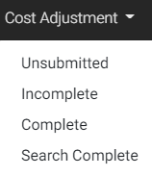

1. **Unsubmitted:**
2. When user selects this menu, it will be navigated to Unsubmitted Cost Adjustments grid.
3. The Cost adjustment requests which are created by Buyer/ MerchOps and if not submitted will come under this Unsubmitted lists.

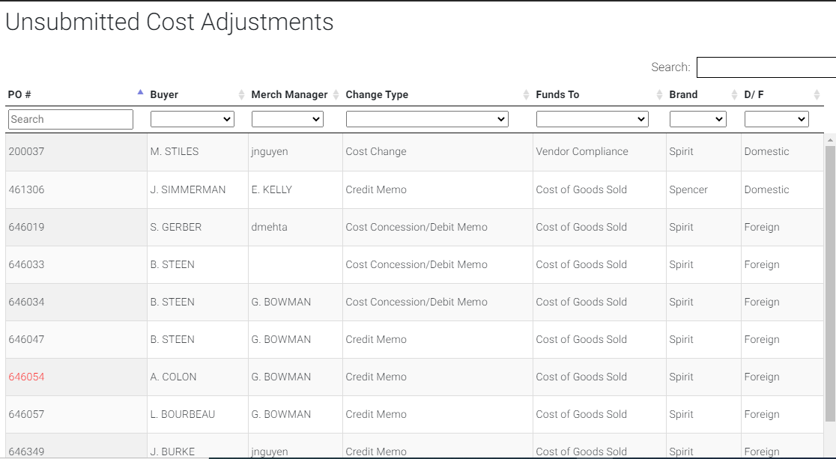

1. Unsubmitted grid consists of PO, Buyer, Merch Manager, Change Type, Funds To, Brand , D/F drop down so that user can filter them as per his requirement.
2. The requests which are rejected / retracted will be available in this grid.
3. **Incomplete:**
4. When user selects this menu, it will be navigated to Incomplete Cost Adjustments grid.
5. The requests which are submitted and whose approval steps are pending will be available in this grid.

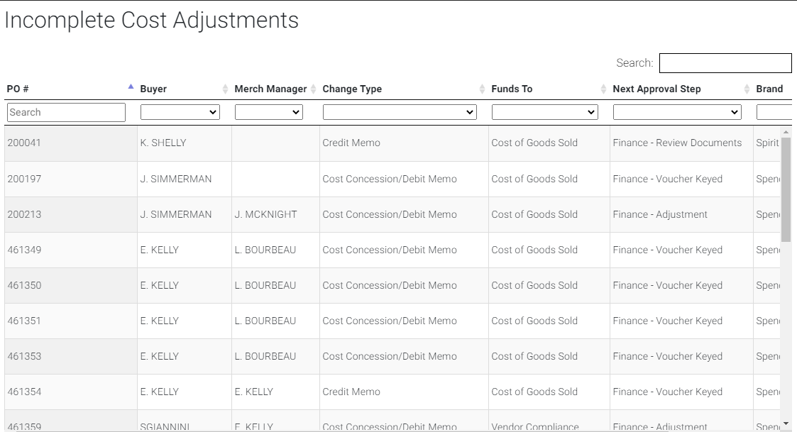

1. Incomplete grid consists of PO, Buyer, Merch Manager, Change Type, Funds To, Next Approver Step, Brand, D/F drop down so that user can filter them as per his requirement.
2. **Complete:**
3. When user selects this menu, it will be navigated to Complete Cost Adjustments grid.
4. The Cost adjustment requests which are Completed by Finance role will be displayed in this grid.

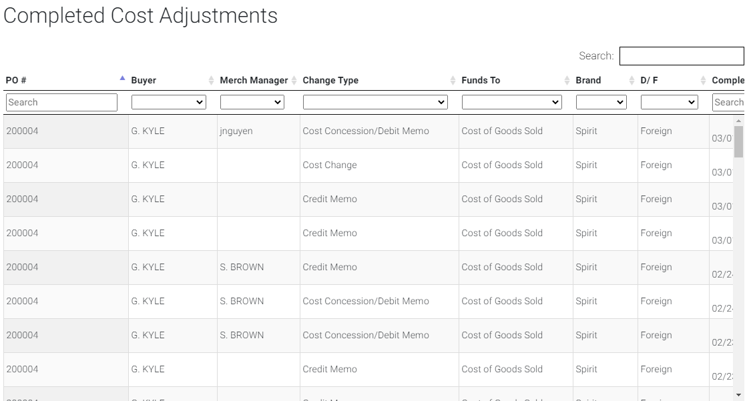

1. **Search Complete:**
2. When user selects this menu, a popup will be displayed with PO Number and SKU.

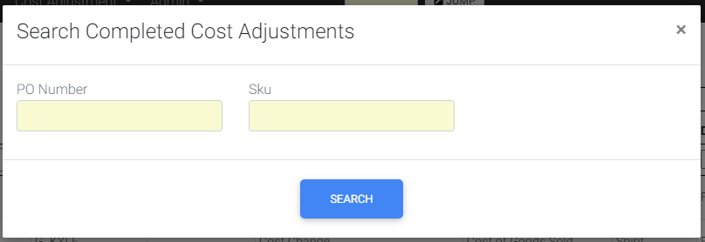

1. User can search the completed adjustment requests either by PO Number or SKU.

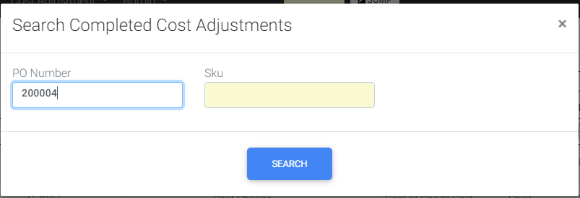

1. Completed Cost Adjustment request with the entered PO Number will be displayed.

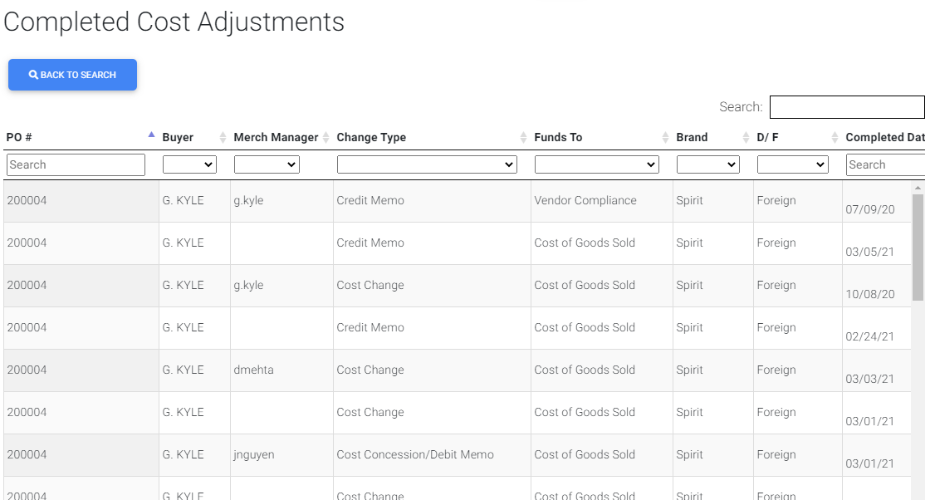

1. This grid consists of PO Number, Buyer, Merch Manager, Change Type, Funds To, Brand, D/F, Completed Date fields.
2. At the top of the grid Back to Search button is visible. When user clicks that button user will be navigated back to the Search Completed popup with previously PO Number/ SKU values.

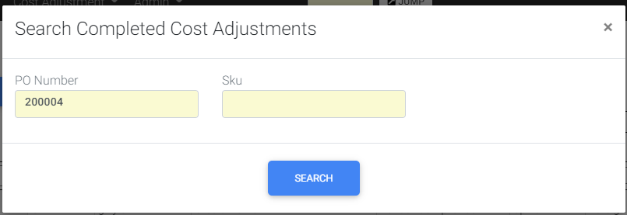

## 1.9 Rules:



## 2.0 Notification Reference:



## 

**\*\*\***